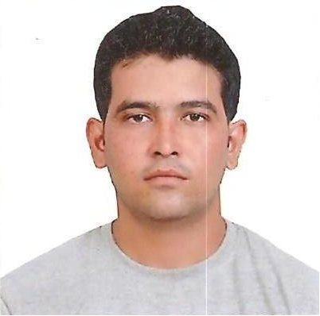
PRABHAT KUMAR SINGH CHAUHAN
D-52,Sec-22 Noida ,
Pin Code- 201301,UP

Email: prabhatkschauhan27@gmail.com

Mobile No: +91- 7827203520

Career Objective

To work with an organization, which encourages innovative ideas, gives opportunities to use multi disciplinary skills and thus helps in portraying a successful career path through a mutually beneficial way.

Professional Background

- MBA (MARKETING & SALES) from IIMT Management College in 2010 (UPTU ).

- B.Sc. (Bio) From Dr. B.R.A. University, Agra in 2005.

- Senior Secondary from K.V.R.R.C. Fatehgarh in 2001(CBSE BOARD).

- High schools from K.V. Army Jodhpur in 1999(CBSE BOARD).

Work Experience
SHARP SIGHT CENTRE(Group Of Eye Hospitals)
( 2010 – 2013 )
- Designation  - Description  - Experience |  | - Worked as Marketing -Incharge.  - Worked in this Organization as Marketing –Incharge.  - 3 Year worked in this Organization
- Responsibilities |  | - Promoting our Hospitals & Doctors.  - Organizing CME (Continue Medical Education and Talk.)  - Organizing Camp Activity.  - Handling the Marketing Team.  - Maintaining relationship with the clients.  - Maximizes the Business & creating awareness in front of new clients.  - Visiting various places for Maximizes the Business.  - Meet RWAs, Associations, Ophthalmologist, Physicians, Optical Shops & Chemist Shops.  - Making Referral Fee of Doctors, Optical & Chemist
VASAN EYE CARE(World Largest Eye Care Hospitals)
( 2013– Till Date )
- Designation  - Description  - Experience |  | - Working as Manager (Marketing & Operations).  - Presently working in this Organization as Manager (Marketing & Operations).  - Still Working in VASAN EYE CARE HOSPITALS since May 2013 to Till Date.
- Responsibilities |  | - Promoting our Hospitals & Doctors & handling Operations of Centre.  - Organizing CME (Continue Medical Education and Talk.)  - Organizing Camp Activity.  - Handling the Marketing Team.  - Maintaining relationship with the clients.  - Maximizes the Business & creating awareness in front of new clients.  - Visiting various places for Maximizes the Business.  - Meet RWAs, Associations, Ophthalmologist, Physicians, Optical Shops & Chemist Shops.  - Making Referral Fee of Doctors, Optical & Chemist.  - Handling Hospitals (Operation) Activity at Centre.  - Meet With Patients & Counseling patient.  - Responsible for Monthly Revenue with Quality Care.

Summer Internship

- Title | - Marketing Strategic in Rico Auto Industry.
- Organization | - RICO AUTO INDUSTRY LTD. Gurgaon (Haryana).
- Description | - Explored about the process of marketing and its attributes and the Functioning of management of MARKETING department.
Project Undertaken
- Title | - Market survey on Consumer Buying Behavior towards Refrigerator.
- Organization | - IIMT Management College Meerut, UP.
- Description | - Surveyed on consumer buying behavior regarding their preference of Brand, demand, features, capacity, deciding person, total sales in a month in the area of Meerut.

Extra Curricular Achievements

Member of the organizing committee of IIMT TRADE FAIR-2009.

Generated 20 prospective leads for JOB CONSULTANCY.

Captain of college Football team in the university.

Active member of N.C.C. – Army wing awarded ‘B’ certificate
Played hockey at state level

Proficiencies and Interests

- Computer | - MS-Office, Internet and email
- Language | - Hindi, English
- Interests | - Traveling to Various Places and interacting with the people.

Personal Details
- Father’s Name |  | Mr. Shiv Kumar Singh Chauhan.
- Date of Birth |  | 30th Aug 1984
- Gender |  | Male
- Marital Status |  | Single
- Nationality |  | Indian

Date: (PRABHAT KUMAR SINGH CHAUHAN)

Place: Signature of Applicant

