C U R R I C U L A M V I A T E
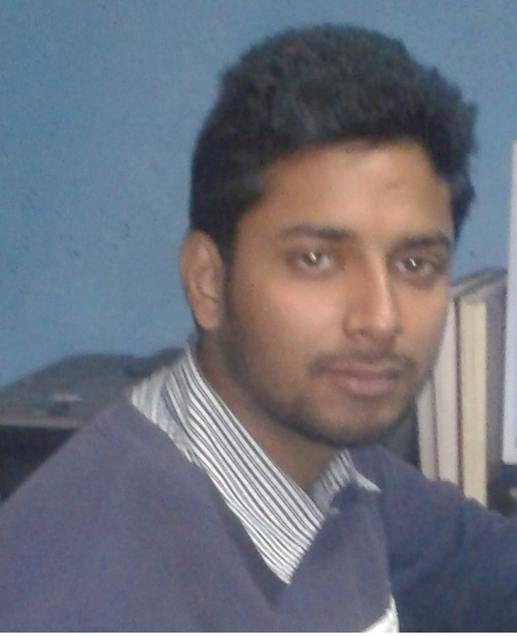
RAHUL KUMAR
HOUSE NO: 18, D-BLOCK, PEERAGARHI
OPP. PACHIM VIHAR (WEST) METRO STATION
NEW DELHI: 110 056
MOB: 9910899462(PERSONAL), 8010262336(HOME)
rah.kr786@gmail.com
r.k1992@yahoo.in

Career Objective:
Seeking a position of Accountant in financial organization in which I can use my experiences and skills in accounting to the fullest extent.
Educational Qualification:

Graduation | - Completed B.Com from University of Delhi (SOL), With 50% Marks, Year-2015
Academic Education | - Complete 12th Standard from CBSE (DELHI), With 62% Marks, Year-2011.  - Complete 10th Standard from CBSE (DELHI), With 69% Marks, Year-2009.

Professional Qualification:

Institute Of Computer and Finance Executive
Computer Course  Accounting Package | - Good Working Knowledge of MS Office 2007 & 2010  - Advance Excel i.e. F Function, PivotTable, Vlookup, Hlookup, Filters etc..,  - MS Word i.e. prints setting, Diagram, Border, Formula etc.  - MS Outlook (Working Knowledge)
Computer Course  Accounting Package | - Tally.ERP9 (Accounting & Inventory Voucher with Taxation)  - LOTUS NOTE (Working Knowledge)  - BUSY 14 Rel 2.4 ( Sale, Purchase and Stock Maintaining

Strength:
- You cannot change the past but you can make the future by changing the present.

Working Experience:

Total Experience is above 3.8 years...

- Gandhi Enterprises (Haldiram Distributer) ______1.4 Year.
(As Computer Operator from March 2012 to June 2013)..,
- Calco Poly Compound Pvt. Lt.d., (Baddli) ______1.10 Year
(As Accountant Assistant form 21th Oct 2013 to 22 July 2015)..,

M/S. Vin Poly Technologies Pvt Ltd. (Naraina)
Designation | Accounts Executive.
Duration | 23th July 2015 (Joining Date) To Till Date.
AT Area of Work | - Work in Tally ERP9, Busy (14, 3.6, 3.4) Accounting Software.  - Knowledge about TDS, Service Tax, Sale Tax.  - Maintain regular books of Excises.  - Book keeping and maintaining day to day accounting records. Recording of day to day transactions like cash, bank, sales, purchase, payment and receipts etc.  - Timely preparation of profit and loss account and assisting in preparing the balance sheet.  - Preparing bank reconciliation and stock reconciliation on weekly and monthly basis.  - Accounts receivable and Accounts payable (Invoicing, payment follow ups and issuing Cheque).  - Finalized the books at the end of the financial year..,  - Maintain Petty Cash Book Daily.  - Sundry Debtors & Creditors Reconciliation timely.  - Salary Calculate,ESI, PF & Bounce of workers..,

Skills
- Hard work & sincerer in working and decision maker
- Understanding & compromise with own colic as well as my senior.
- Thrive on challenge & Pressure in work and also positive nature.

Demographic Information

Father’s Name : Sh. Purshotam Lal
Date of Birth : 07th Oct 1992
Gender : Male
Marital Status : Unmarried
Nationality : Indian
Language Known : Hindi & English, Punjabi

DECLARATION

I certify that the particular given above by me are true to the best of my knowledge and Belief.

Signature

(RAHUL KUMAR)

