RESUME
Permanent Address:  Kunnettukara (h)  South pampady p.o  Kottayam dist  Pin no: 686521  Date of Birth:  27-11-1989  Sex:  Female  Nationality:  Indian  Domicile:  Kerala  Name of Father:  Thomas K.J  Interests & Activities:  Cooking  Traveling  Hearing music  Other Details:  Passport No:K7240120  Languages Known:  English  Malayalam  Tamil(speak) | 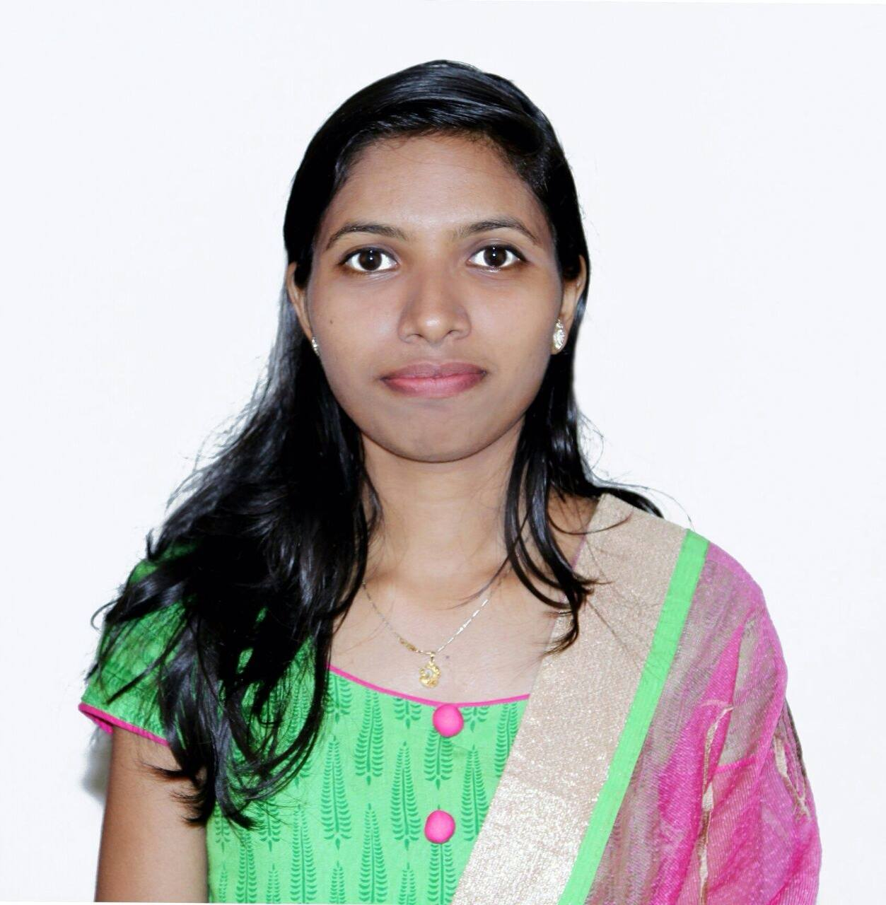  CINCY K THOMAS  cincykthomas@gmail.com  +917034933466  OBJECTIVE  To contribute my functional and technical abilities in the field of health care services, and my qualification contribute to the growth and development of the organization, in a leading role, keeping mind the fact that learning never ends.  EDUCATIONAL QUALIFICATION  MHA (Master of Hospital Administration) (2013-2015)  Institution :Little Flower Institute of Medical Sciences and Research Angamaly  University : K.U.H.S( LF ANGAMALY)  BSc NURSING (2008-2012)  Institution : Rani meyyammai college of nursing, Chidambaram, Tamil Nadu  University : Board of Examination for Bachelor of Science in Nursing, Tamil Nadu  Year of passing : 2012  STRENGTHS  - Eagerness to Learn  - Self Confidence  - Ability to Deal with People Diplomatically  - Quick Learner  - Adaptable to any Situation  COMPUTER SKILLS  - M.S. Word, M.S. Excel, M.S. PowerPoint

ACADEMIC CHRONICLE

Year of Passing | Institution | Board/University | Degree Name | Percentage
2015 | Little Flower Angamaly | K.U.H.S( LF Angamaly) | MHA ( Master of Hospital Administration) | 1st year 60%  2nd year 66%
2012 | Rani meyyammai College of nursing | Board of Examination for Bachelor of Science in Nursing, Tamil Nadu | BSc nursing | 65%
2008 | Don Bosco Higher secondary school, Kottayam | Kerala State Board  (HSC) | Class XII | 76%
2006 | M.G.M High school, Pampady, Kottyam | Kerala State Board  (SSLC) | Class X | 76%

PROJECT EXPERIENCE
- I have done my 1st year project “A STUDY TO ASSESS THE LEVEL OF STRESS AMONG SUPPORTIVE STAFF IN SANJOE HOSPITAL PERUMBAVOOR
- I have done my 2nd year project “ A STUDY ON LEADERSHIP STYLE OF SUPERVISORS AND RETENTION OF EMPLOYEES IN SAMARITAN HOSPITAL, PAZHANGANADU.

.

PARTICIPATION AND ACHIEVEMENTS
- Active member in college and school clubs
- Active member in various clubs

DECLARATION
I hereby declare that the above mentioned details furnished by me are true and correct to the best of my knowledge and belief.

Place: KOTTAYAM
Date: 08-03-2016 Cincy k thomas

