CURRICULUM VITAE
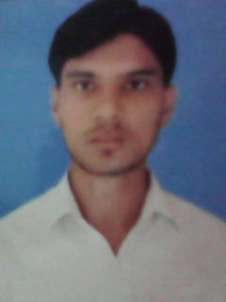
MAHESH KUMAR
Gali No.-6 H.No.-197,
Sehatpur, Faridabad (Haryana)
Contact No.: +91-9990838328, 8287969734, 7532947193
E-Mail: thakurmaheshkumar311@gmail.com

Career Objective

.
To associate myself with a reputed organization with an opportunity to apply and refine my Management, analytical and problem solving skills while working towards achieving organizational objectives.
Knowledge and ability to the fully.

Academics

Year | Course | Board/University | College/School
2008 | 10th | U.P. Board | Allahabad University
2011 | 12th | U.P. Board | Allahabad University
2012-13 | DMLT | Punjab Technical University | DPMI

Professional Qualification:-

- D.M.L.T. Passed from Punjab Technical University in year 2011-2012.

Other Qualifications

- Computer Basic Fundamental
- MS. Office: World, Excel, and Power Point

Internship:-

- Saras Hospital in Badarpur Border New Delhi.

Work Experience:-

- 3 Months Worked In Medicentre Lab B-13 Shivalik Malviya Nagar New Delhi.
- 10 Months Worked In Kapoor Medical Centre E-18 Naraina Vihar New Delhi.
As a Lab Technician.
- Presently Working in Accuster Pvt. Ltd. Company Manesar Haryana.
As a Lab Technician

Instrumental Knowledge:-

- Sysmex. X.21 Fully Automatic Cell counter ( Hematology)
- BS-300 Fully Automatic ( Biochemistry)
- Roche AVL Electrolyte Semi Automatic Analyzer (Biochemistry)
- Chem-7 Semi Automatic Analyzer ( Biochemistry)
- BC-2800 Fully Automatic Cell ( Hematology)
- Mini Vidas Fully hormones analyzer (Elisa).
- Mini Mobile Lab (Portable Lab).

Clinical Pathology:-

- Routine examination Like Urine, Culture & Sensitivity.

Personal Details

Professional : Lab Technician
Date of Birth : 25May, 1994
Marital Status : Unmarried
Father’s Name : Sh. Mahipal Singh
Nationality : Indian
Gender : Male
Religion : Hindu
Interest and Activities : Reading Books, Watching Movies
Languages Known : English, Hindi

Declaration

I hereby declare that the information furnished above is true to the best of my knowledge.

DATE: MAHESH KUMAR
PLACE:

