CURRICULUM VITAE

SIJITA SAKARIA 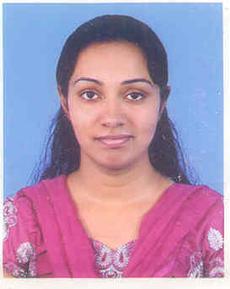

N-21/C-2,DILSHAD GARDEN,DELHI
09953660968/22110832
EMAIL ID: Sijita85@yahoo.com

STAFF NURSE (RN)
Bachelor of Nursing

WORK EXPERIENCE (TOTAL 5 YRS)

PAKISTAN EDUCATION ACADEMY,DUBAI

- Worked as a School Nurse from 31.8.2014 to 5.1.2016
- Duties included first aid administration,health education,vaccination,record keeping.

MAX HOSPITAL,DELHI,INDIA

- Worked as a Staff Nurse from 26 Aug 2009 to 30th Sep 2012
- Duties included medicine administration,iv cannulation,Collection of samples,CTG monitoring,neonatal care.

CANCER HOSPITAL,MP,INDIA

- Worked as a Clinical Instructor from 17.9.07 to 21-01.09
- Duties included Supervising students,demonstrating procedures ,taking lectures.

EDUCATIONAL BACKGROUND AND LICENSES
Dubai DHA License Isssued December 2014

Delhi Nursing Council Registered June 2009
Jiwaji University BSc Nursing June 2003-2007
Greenfields Public School Senior Secondary May 2003
St.Josephs Academy High School May 2001

PERSONAL INFORMATION:

Date of Birth : June 19,1985
Sex : Female
Citizenship : India
Visa : Husband’s visa
Civil Status : Married
Religion : Christian
Languages : Fluent in English,Hindi and Malyalam
Computer Skill : Have basic knowledge.

SIJITA SAKARIA DELHI

