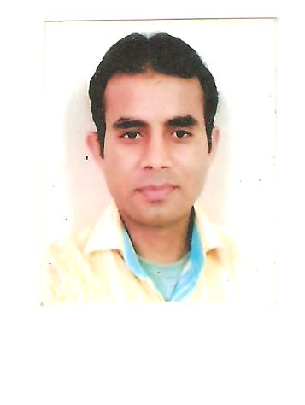
CURRICULUM – VITAE

MD. HASMUDDIN

RZ-28 (889)Lane No. -5, Main Sagarpur
New Delhi – 110046.
Contact No.: 9810763656, 9250535839.
E-mail:- mdhasmuddin@yahoo.co.in
mdhasmuddin14@gmail.com

WORK EXPERIENCE:-

- Presently working as Business Development Manager in Anand Hearing Care
Pvt. Ltd. From 10/02/2014 To Till Date.

- Ability to work effectively across functions and lead teams
- Team Management: Scheduling and monitoring training sessions and exercises.
- Marketing Health Care: Corporate/Trade Marketing /General Awareness programs.
- Referral Business: Maintaining relations and generating regular business.
..
- worked as as Business Development & Corporate Affairs Manager in
Kukreja Hospital & Heart Centre Pvt. Ltd.
From 15/05/2013 To 08/02/2014.
Key Result Areas:
- Team Management: Scheduling and monitoring training sessions and exercises
- Revenue generation.
- Building relationship with key persons or influential persons.
- Visit major corporate and try to empanel with Hospital.
- Increase brand value of Hospital.
- Organizing Camps and Talks.
- Organizing CME.
- Guiding and referring patient to the relevant Doctors for their illness
- worked as Medical Assistant & Coordinator ( operation ) to Spine
Team in PRIMUS SUPER SPECIALITY HOSPITAL CHANAKYAPURI.
From 27/07/2009 To 10/04/2013.
- Worked in Ganesh Diagnostic & Imaging Centre Private Ltd as
Marketing executive & Public Relation Officer (P.R.O) from November 2008
to June 2009.
- Worked in Dr: Batra’s health Care Centre Private Ltd as Customer Care
Executive (C.C.E.) & Front Desk Officer (F.D.O.) from Aug 2007 to Oct 2008.
ACADEMIC QUALIFICATION:
- 10th passed from B.S.E.B. Board.
- 12th passed from C.B.S.E. Board.
- Graduation B.A (from Delhi University).
- Pursuing M.B.A From SMU ( SIKKIM MANIPAL UNIVERSITY )
PERSONAL DETAILS:-
Father’s Name : Sh. Md: Israil
Date of Birth : 15th May 1986
Gender : Male
Marital Status : Single
Languages Known : Hindi & English
Nationality : Indian
Religion : Muslim
Hobbies : Listening Music, Watching Movies & Playing a
Snooker.

Date---------------

Place-New Delhi ( Hasmuddin )

