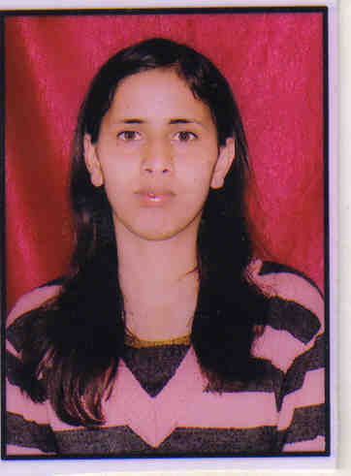
CURRICULUM VITAE

MAMTA SATI

Date of Birth: 5th July, 1991
Contact No: +91-8860466979, Email: mamtasati91@gmail.com

CAREER OBJECTIVE:-

Masters of Health Administration and looking for challenging opportunities in healthcare and related sector.

AREA OF INTEREST:-

- Monitoring & Evaluation
- Administration.
- Quality Assurance comply with NABH & NABL standards.

EDUCATIONAL QUALIFICATION:-

PROFESSIONAL EDUCATION

- Masters of Health Administration, from Sai Institute of Paramedical and Allied Sciences - Dehradun, affiliated to Uttrakhand Technical University, (2012-2014).

- B .Sc in Bio group from Kumaun university Nanital (2008 – 2012)

ACADEMIC QUALIFICATION

- 10th class CBSE - 60%
- 12th class CBSE - 60%

PROFFEESIONAL EXPERIENCE:-

Currently working at Vision Eye Centre (29 Jan 2015 to till now) also with billing department & Quality Co-coordinator.

Job Responsibilities as a Billing & co-coordinator-:
- Evaluated patient for suitability, completeness and correctness of health data.
- Recorded data electronically for collection, storage, analysis, recovery, and reporting.
- Arranged and maintained data for medical database and registries.
- Handled all kinds of insurance/Panel claims, including private.
- Protected patients’ healthiness information for privacy.
- Handling the proper payment procedure regarding to Patient and submitted it to Account department.
- Coordinate with the concern department regarding the query of patients related to surgery & other medical information.
- Handling all government panel documents of surgery and OPD.( Submission of documents, query resolving , claims status)

Training experience:

- Did an internship in Front office in OPD & IPD IN RG. Stone from (15 Nov 2012 TO 14 Feb 2013)., dealing with patient from their admission to their discharge and also with billing department.

- Did an internship in IPD IN Sarvodaya Hospital faridabad from (1 April to 03 July 2013)., dealing with In- patient from their Feedback analysis in Quality department. & CAPA analysis.

- Did an internship from Bansal Hospital in QUALITY DEPARTMENT from (14 Jan 2014 to 25April to 2014)

- I have done in my training-:

- Analysis of feedback form
- Staff awareness during NABH
- Retrospective audit
- Concurrent audit
- Worked on quality care indicator
- Capa analysis

OTHERS ACTIVITIES:-

- Worked as Research consultant in ASTRON. Did a project for USAID (UNITED STATE AGENCY OF INTERNATIONAL DEVELOPMENT. FOR QUALITY check of maternal health in rural areas.(26 October for 12 Day).

KEY SKILL AND STRENGTHS-:

- Good Working
- Capture Good Overall Knowledge of Work in hand
- Punctual & quick learner

PERSONAL DETAILS:-

- Father ‘s Name : MR. R C Sati
- Date of Birth : 05.01.1991
- Sex : FEMALE
- Language known : HINDI/ENGLISH
- Marital status : UNMARRIED

