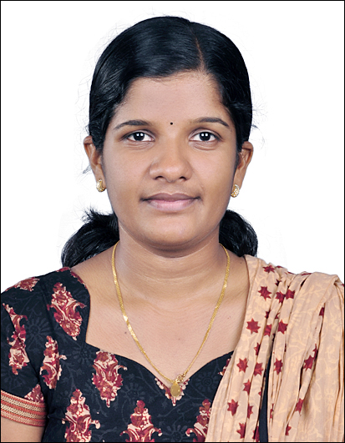
CURRICULUM VITAE

Soumya Raj
Remya Sadanam
Vellappara P.O,
Konni, Pin: 689691
Pathanamthitta (Dist) Mob: +919562412388, +919560080097
Kerala, India. E-mail: soumyaanu1@gmail.com

Career Objective:-

To establish my career independently in the field of Nursing with excellent professional skills with interest and improve my skills in the field of Nursing which effectively utilizes my medical knowledge in Health Department and contribute to the growth of the organization in a progressive, challenging, and dynamic manner.

Qualities:-

I have quality of maintain good interpersonal relationship with other health personals sincere and dedication to my profession and I am punctual and systematic at work.

Academic Qualification:-

Qualification | Board/ University | Year
10+2 | Board of Higher Secondary Examination, Kerala | 2005
S S L C | Board of Public Examinations, Kerala | 2003

Professional Qualification:-

Qualification | Board | Institution | Year
Diploma in General Nursing & Midwifery | Kerala Nurses and midwives council | School of nursing NSS medical mission hospital, karukachal | 2010

Professional Employment History:-

- I have total Three years working experience as a Staff Nurse
- Working experience as a Staff Nurse in Kokilaben Dhirubhai Ambani hospital & medical research institute Mmbabi since 17.09.2012 to 30.01.2013 cardiac OT.
- Worked as Staff Nurse in Sterling Hospital Rajkot since 19.09.2011 to 03.06.2011 in medical surgical ward.
- Worked as Staff Nurse in since NSS Medical mission karukachal 01.07.2010 to 30.06.2011 in Operation Theater.

Duties & Responsibilities:-

- Assessment, Planning, implementation & Evaluation of the nursing care requirements of their allocated patients.
- Share professional knowledge & skills with all colleagues.
- Demonstrate nursing procedures & supervise junior nurses and student nurses, and Para-nursing staff.
- Organization and management of nursing care.
- Maintain the core values of profession
- Efficient recording of all necessary documentation.
- Timely identification and communication of any issues to ward manager.
- Maintain an effective interdisciplinary communication process.
- Participating in all ward and hospital nursing communication process.
- Attend all mandatory education sessions.
- Be a preceptor to students and newly appointed staff.

Cases Encountered:-

- All Medical & Cardiac Emergencies
- Liver Transplantation & Renal Transplantation
- CRRT
- Intubation
- Bronchoscopy
- Lumber puncture
- Ventilation
- ICD Insertion
- Central Venous Catheterization
- Arterial Catheterization
- Deflbrillation
- Using of Inotrops, Heparin, Corderan etc
- Taking and doing ABC & VBG

Equipments Used:-

- Ventilators
- Cardiac Monitor
- A3 Monitor
- Defibrillator
- CRRT Machine
- ABG Machine
- 2D Eco Machine
- ECG Machine
- AMBU Bag
- C Circuit
- Ultra sound Machine
- Bipap
- CVP Monitoring
- Warmer
- Multifit
- Sonosyte Machine
- Syringe Pump/ Infusion pump
- Pulse oximetry
- Crash cart
- CPR Trolley
- Nebulizers
- Suction Apparatus
- Glucometer

Strengths /Skills:-

- Affinity and dedication towards medical profession
- Focus concerns & Interest in my endeavors
- Good relation with patients
- Confident in my skills and knowledge.

Personal Details:-

Date of Birth : 25/04/1988
Gender : Female
Martial Status : Married
Nationality : Indian
Religion : Hindu
Father’s Name : Rajeshekharan nair
Languages Known : English, Hindi, Malayalam

Passport Details:-

Passport No : J8411387
Date of Issue : 07/07/2011
Date of Expiry : 06/07/2021
Place of Issue : TRIVANDRUM

Declaration:-

I hereby declare that all the information and facts given above are true to best of my knowledge and that I am in possession of the documents in proof to the claim made in this resume.

Place:
Date: Soumya Raj

