CURRICULAM VITAE
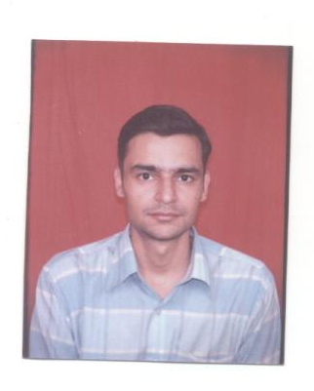

SACHIN VERMANI
542, Nimri Colony, Near Ashok Vihar, Delhi-110052 (INDIA)
Ph:- 9891504600, 9718594600 sachin10765@gmail.com

Presently associated with Maharaja Agrasen Hospital under Accounts Department. Also worked with HOC_AGE ENGINEERING LTD as a Manager. Extensive experience in handling the entire manufacturing unit with 25000 sq ft. working area.. Proficient in maintaining excellent relations with clients to generate avenues for business. An effective communicator with excellent relationship management skills.

CARRER OBJECTIVES-

To put full efforts with devotion and sincerity in work entrusted to me, there by maintaining high professional standards and thus worth to the potential and qualifications.

PROFESSIONAL EXPERIENCE:-

From December 2007 to till now Working at Maharaja Agresan Hospital as a Sr. Executive under accounts, also working in panel department to deal with Panel (TPA) Patients for their Cashless Treatment. Currently working at cash department. It is a ISO 9001:2000 certified 380 bedded, multi-specialty and fully computerized hospital in West Delhi & approx. 1000 employees working there.

April 2002 to November 2007 worked with HOC_AGE ENGINEERING LTD as a Manager. Company manufacturing AC motor run & start (electrolytic) Capacitors in its manufacturing unit in Distt sonepat (Haryana), India.& do business all over INDIA (some Export). As a Manager with all types of work like sales tax, income tax, Accounting, ISO, ISI, Marketing, Purchasing, wages, daily expenses etc.

Worked with PADAM ELECTICALS LTD in 2000 to 2002 as a Marketing executive, accounts assistance.

Also worked with CITI BANK in 1999 as a Marketing Executive.

JOB PROFILE
- General Administration
  - Collection of cash above 30 lac per day, to prepare IPD billing & OPD silps.

  - Involved in providing administrative & clerical support in the Directors office.
  - Accountable towards maintains accounts books, bank operation, cash etc.

  - Assessment of the performance of the vendors based on various criterions such as quality, delivery in time, credit terms etc.

  - Maintains Quality Policy of ISO 9001:2000, records of ISO & also maintains records of BUREAU OF INDIAN STANDARDS.

EDUCATIONAL QUALIFICATIONS:-

- Graduation in the Commerce Stream form DELHI UNIVERSITY.

- Senior Secondary from the CENTRAL BOARD OF SECONDARY EDUCATION, New Delhi

- GNIIT Computer Course from NIIT, Delhi.

- One year Certificate course in Computer Application from “ TOOL ROOM & TRAINING CENTER” Delhi

PERSONAL PERFORMA:-
NATIONALITY : Indian

DATE OF BIRTH : 10th November 1978

MARITAL STATUS : Single

EXPECTED SALARY : As per industry norms

If given the opportunity, I promise to abide by the rules of the organization and work to the best of my abilities with conviction.

(SACHIN VERMANI) Date:-

