CURRICULUM VITAE
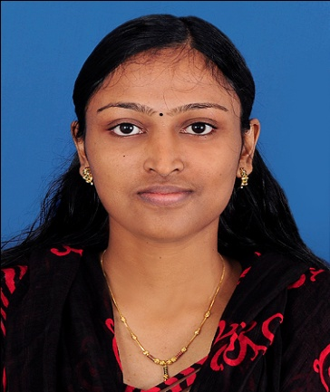

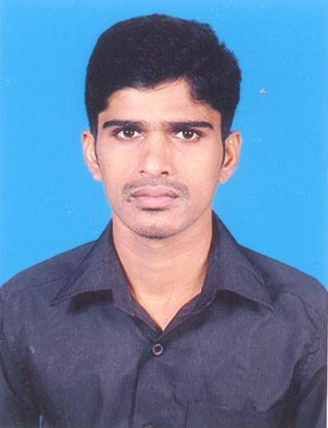

PERSONAL DETAILS

Name JUNA VIJAY L
Sex Female
Date of Birth 06-05-1992
Father’s Name Vijayan B
Religion Catholic
Nationality Indian
Marital Status Single
Mail Id verginjunavijay06@gmail.com

Permanent Address Kamala Vilasam, Bunglow
Nilamamoodu, Karakonam PO
TVM Dt,
Kerala – India -699504

Mob no 9809716750, +91 9995200509

Languages Known English, Malayalam

PERSONAL QUALITIES

- Comprehensive problem solving abilities.
- Ability to deal with people friendly and inquisitiveness to learn new things.
- Team facilitator and organizer, fast grasping and highly responsible.
- Quick adjustment to the new situation and work.
- Good personality, character ethics and hard worker.

Objectives

- To work in a professional environment so as to enhance my skills and work to my full potential.
- Leads to a corporation among team members in conjunction for the objective of the organization.
- To attain a good position in among the team members and the organization with hard work and team spirit.

EDUCATIONAL QUALIFICATION

Course | Board | Name of the Institution | Marks | Year of Passed
Master of Applied Science in Biomedical Instrumentation | MG University, Kottayam, Kerala | School of medical education, Arppukara, Kottayam, Kerala | 1st class | 2014
BSc Physics with Computer Application | Kerala University | Emmanuel College Vazhichal, TVM, Kerala | 1st class | 2012
PLUS TWO | KERALA HIGHER SECONDARY EXAMINATION | St. John’s HSS Undancode, TVM, Kerala | 1st class | 2009
S.S.L.C | Kerala State Board | St. John’s HSS Undancode, TVM, Kerala | Distinction | 2007

EXPERIENCE

- 1 Year Experience as an Assistant Biomedical Engineer in SK Hospital, TVM, Kerala.
- Still Working experience in ATHANI Hospital Kozhinjampara, Palakkad as a Biomedical Engineer In charge from 8th January 2016

declaration
I here declare that the above said information is true in the best of my knowledge and belief.

Yours Respectfully
Place: Palakkad
Date : 10/10/2016 JUNA VIJAY L

