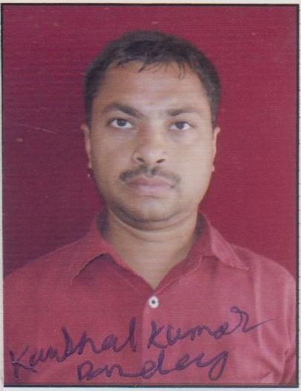
cUrriculum vitae

Kaushal Kumar Pandey

Khesra No-71/2, Vill.-Ghevra,

Near Ghevra Railway Station, New Delhi-110081

Contact No: +8130597207/9953876316

E-Mail: kaushal.pandey0@gmail.com

Objective
To input value components in Account development role where I can utilize my experience & skills more optimally with view to meet & exceed role requirements along with self-growth.

Education Qualification

Education | Year of Passing | University / Board | Percentages | Class
B.COM (ACCOUNT) | 2003 | PATNA UNIVERSITY | 62% | Ist Class
12th | 2000 | B.I.E.C PATNA | 62% | Ist Class
10th | 1998 | B.S.E.B PATNA | 45.45% | IInd Class

AREAS OF STRENGTH

- Energetic and proven team member.
- Good analytical and problem solving skill.
- Leadership skills involving managing developing and motivating teams to achieve their goals and objectives.

- Dedicated to maintaining high quality.

HIGHLIGHTS OF PROFESSIONAL EXPERIENCE

Organization: Barun & Co (Charted Accountant firm)

- Boring Road Patna.
- Department: Audit
- Designation: Auditor
- Duration: 16 Jan2005 to 6 Jan 2006

Organization: Suryakant & Associates

- Shivpuri Patna.
- Department: Audit
- Designation: Auditor
- Duration: 17Jan 2006 to 10.June 2006

Organization: C. T.S Express Logistic Pvt. Ltd.

- Bhosari Pune
- Department: Account.
- Designation: Executive
- Duration: 10 July 2006 to 15 Jan 2015
Organization: C. T.S Express Logistic Pvt. Ltd.

- MAYAPURI DELHI
- Department: Account.
- Designation: Regional manager Finance
- Duration: 19 Jan 2015 to till date

Job Profile:

-Preparing Invoices and follow up to client for payment receive.
-Preparing vendors payment and vendor reconciliation.
-Preparing Monthly Information Report (MIS), Bank Reconciliation Sheet (BRS) , Voucher
Transaction & Preparing Proper Account Report.
-Responsible for Updating Account Record & Book Keeping.
-Bill Collection from Party.
-Maintain General Ledger.
-Responsible for documentation.
-Preparing and analyzing accounting records and financial statements reports.
-Maintaining track record of company’s expenses.
-To maintain records of payment information.
-Handled customer inquiries, researched problems and developed solutions.
-Studying the reports given by auditors and CA and submitting it to the Management.
- TDS & Service tax knowledge.& also handle overdraft monitoring & control funds /fright outstanding customer filtration according to company credit policy.cash handling & fund management.

Other Qualification

- MS office
- Tally 7.2
- ERP & CIC (Certificate in computing)

Personal Information

Name : Kaushal Kumar Pandey
Date of Birth : 15 Jan 1983
Gender : Male
Marital status : Married.
Language known : English, Hindi, Marathi.
Permanent Address : Village -Jagdishpur, Post- Jarang Rampur.
Dist- Vaishali (Bihar)
Contact No : +8130597207

Do here by declare that the above statements are true to the best of my knowledge and belief.

Date: / /201 Yours Faithfully,

Place: New Delhi (Kaushal Pandey)

