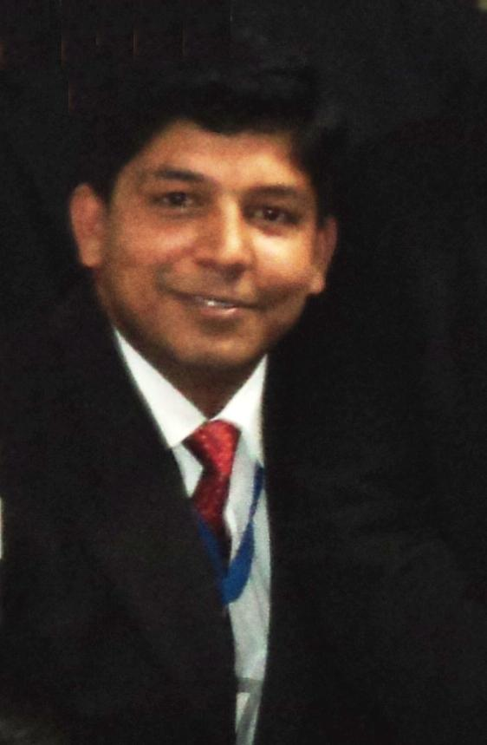

RESUME

Phone: 09711662545
SATENDER KAUSHIK Email: sk.rhpv@gmail.com

Objective: To obtain a challenging carrier in security along with the utilization of skill and professional expertise.

Summary of Qualification:
Experienced and dependable security Supervisor dedicated to ensuring the safety of employees, visitors and minimizing potential losses.

Education Qualification:

- 12th (HSC) from U.P. Board in 1997.
- 10th (SSC) from U.P. Board in 1995.

Additional Qualification:

- One Year Diploma of computer operating.
- One week First Aid Course from St. John Ambulance.

Current & Previous Working Experience:

1. Presently working with Satyam Cineplexes Ltd.
C/o Inox Movies as a Executive Security & Admin.
08.12.2014 to till date.

2. Job Worked with Park Ascent Hotel Sec-62, Noida (U.P.)
As a Security Supervisor (Oct 2012 to 04.12.2014)

3. Job Worked with Radisson Blu Paschim Vihar New Delhi.
as Security Supervisor (Dec.2010 toOct 2012)

Job Responsibilities:-
On the rolls of company as an “Security Supervisor” in the Security Department
Reporting to the Security Officer and do officiating in the absence of security officer
. As a Security Supervisor, I responsible for the following:

- Motivating the subordinates for the better performance & up selling with proper training.
- Responsible for coordination of the department with other departments.
- Looking after security & administration & hotel staff transportation.
- Handling the medical emergencies of guest and employees.
- Maintaining/Management of Time office handling and record, of 350 hotel staff.
- Departmental stationery procurement and management.
- Handling fire hazards and other crisis in the hotel.
- Issuance of the Contractor Gate Passes to the contractor’s staffs and keeping a record.
- Management of Returnable and non-returnable gate passes
- Access control and material control and traffic control in the hotel.

Details of Sectional Job of Responsibilities:-
- Inward material register
- Contractual materials
- Walky Talky register
- Staff article register
- Project Inward register
- Key management register all Register & Records
- First aid record & Replenishment
- Courier
- Up keeping of all register
- Serially maintaining record flies & register
- Old Record Storage
- General Store Management
- FTC / Banquet casuals register
- Garbage record
- Staff pickup & drop register
- Industrial trainee register
- Car checking register (Eakus)
- Contractual Banquet Casuals register
- Doctor`s Register
- Car Movement Register- hotel fleet & vendor fleet
- Fuel Register
- Hotel Cars Service Records
- RT Register
- Overall Training
- Lost & Found
Providing/maintaining Healthy and safe environment for Guest and employees

4. Job Worked UNITECH AMUSMENT PARK LTD (Under Panzer Security Pvt Ltd).
As Security Supervisor. (24th Aug.2007 to 26th sep.2010)

Skills:

- Remarkable ability of security risk management..
- Great communication, interpersonal and presentation skills.
- Knowledge of local laws.
- Deploy and manages team of security personnel.
- Responsible for safeguarding assets and Office property.

Highlights:

  - Knowledge for Fire Fighting.
  - Training for lifeguard for YMCA Sports Complex New Delhi
  - Training for lifeguard for Delhi Swimming Association New Delhi
  - Got 2nd rank in state level swimming Competition which was held in the month of Aug 2007

Personal Detail:
Date of Birth : 5/06/1980
Gender : Male
Marital Status : Married
Nationality : Indian
Language Known : Hindi & English
Address : H No-53 Sultan Pur Mazra
Extension, Delhi-110086

Date:
(Satender Kaushik)

