ANIMESH DAS 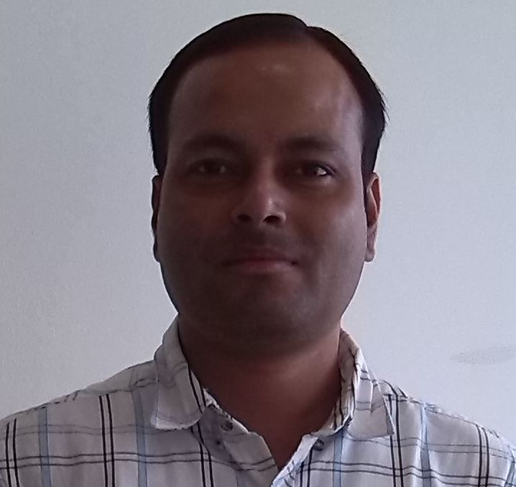

PGDM with around 8+ yrs of experience in Operations/Hospital Management
Key Skills: Managing Hospital Operations in “Irene Healthcare Pvt. Ltd” at Irene Swasthik Hospital, Najafgarh, New Delhi (A 55 Bedded Multi-specialty Hospital) and revenue growth.

Brief Profile
Work Experience | : | 8+ Year(s)
Current Employer (Designation) | : | Irene Healthcare Pvt. Ltd., (Manager-Operations)
Current Annual Salary | : | INR 8.40 Lac(s) Plus Annual Bonus
Functional Area (Role) | : | Hospital Management / Operations
Industry | : | Healthcare
Highest Degree | : | PGDM
Current (Preferred Location) | : | Nazafgarh, New Delhi
Date of Birth (Gender) | : | 21st June 1979 [Male]

Summary of Skills & Experience
Summary
Skills: MS Office, Internet

Trainings:
“Retail Sales techniques” and “Customer Relationship Management” at Religare Wellness.

Work Experience

Duration : October 2013 – Till date
Company : Irene Healthcare Pvt. Ltd.
Designation : Manager Operations
Job Profile : Hospital Administration

Duration : June 2012– October 2013
Company : Davita Nephrolife (I) Pvt. Ltd
Designation : Facility Administrator (For 2 centers)
Job Profile : Hospital Administration

Duration : June 2011 – June 2012
Company : Eye Q Vision Pvt. Ltd
Designation : Operations Manager
Job Profile : Hospital Administration

Duration | : | August 2010 – May 2011
Company | : | Glindia Natureceuticals Pvt. Ltd.
Designation | : | Business Development Manager
Job Profile | : | Managing sales & Operations of Retail stores
Duration | : | August 2007 – August 2010
Company | : | Religare Wellness Ltd
Designation | : | Store In-Charge
Job Profile | : | Managing Store sales & Operations

Education
UG | : | B.Sc (Zoology), from Gauhati University
PG | : | MBA/PGDM from IMT-Ghaziabad 2010, Gurgaon centre.

IT Skills
Skill Name | Version | Last Used | Experience
Microsoft Office | 2000,XP,7 | Till Now | 5 yrs

Affirmative Action
Category | : | General
Physically Challenged | : | No

Work Authorization
Countries authorized to work in: India and all internationals.
Job Type: Permanent
Jobseeker Employment Status: Full Time

Candidate Resume
ANIMESH DAS
Palwal, Haryana, Mobile-9650056702
E-mail: alrg2001@rediffmail.com
PROFILE
* Competent and Result Oriented professional offering over 8+ years of sterling experience across Operations Management, Business Development, Sales and Marketing, Team Management; currently spearheading as ‘Manager-Operations’ with Irene Healthcare Pvt. Ltd at Irene Swasthik Hospital, Najafgarh a 55 bedded Multi-specialty hospital.
* Recognized as a proactive individual who can rapidly identify business problems, formulate tactical plans, initiate change and implement effective business strategies in challenging environments to enhance profit generation.
* Demonstrated ability to manage human, financial and material resources towards the achievement of stated targets/ objectives, to plan and manage work programmes and to lead, motivate and provide effective guidance to a team of professionals.
* Expertise in working in a fast-paced environment and consistently prioritizing tasks to meet deadlines, coupled with excellent interpersonal skills, initiative, attention to detail, and follow-through skills.
* Excellent communication skills- both oral and written with good presentation skills.
* Dedicated and focused individual, determined to add value to the organization I work for, through my l knowledge and innovative ideas.
* Result oriented and determined professional, seeking to provide managerial / commercial support to the corporate industry to ensure distinct advantage in the competitive global market.
* Technically proficient in proficiency in Microsoft Excel, Word & PowerPoint.
Core Competencies
Strategic Planning/Management, Team Management & Development, Sales and Business Development, Operations Management, Customer Relationship Management, Process Improvements, Coordination, Creative Thinking.

PROFESSIONAL EXPERIENCE
Irene Swasthik Hospital, Najafgarh
Manager- Operations
Managing sales & operations of Irene Healthcare Pvt. Ltd at Irene Swasthik Hospital, Najafgarh, New Delhi (A 55 bedded Multi-specialty Hospital).
*Charged with proper management & accountable for the performance of the hospital, including meeting the set business targets. Doing proper catchment’s analysis for getting new patients.
*Strategizing for converting the hospital into more profits; planning activities for Business promotions; Deciding on staff roastering; Coordinating for strategic alliances with other corporate/schools/RWAs/Sr. Citizen Clubs, etc; Business promotion through Corporate Tie ups, Conducting Health Check-Up Camps, improving the profits, focusing on excellent customer service and Customer retention and referrals. Maintaining and helping in Consultant hiring and engagement.

MAIN JOB RESPONSIBILITIES
a) To maximize sales and operating profit of the hospital in line with company objectives and preparing the monthly Marketing plan to achieve the objectives and growth over last month.
b) Monitor and continuously seek to understand commercial environment, local trading patterns, competitor activity and market trends in the hospital sector and their impact.
c) Monitor the handling of customer complaints in line with Company policy
and Development courses. Taking care of HR, Accounts, marketing and Clinical issues.
d) Ensure that staff adopt and adhere to the company dress code, protocols in order to promote a positive and professional image at all times.
e) Ensure expectations and priorities are communicated to staff and regularly review and provide feedback on staff’s performance against expectations.
f) Carry out regular and relevant in-clinic training and enroll staff on relevant Learning Maintain high standards among all the other competitors and met patient satisfaction.
g) Maintain hygiene and cleanliness in accordance to set guidelines.
h) Provide department reports to the management on a daily basis.
i) Monitor sales performance against last year, last week and budget on a daily and Weekly basis and to give feedback to managers and also to communicate to staff.
j) Inventory and Purchase Management of the hospital.

CREDENTIALS
Post Graduation Diploma in Management (Retail) 2010 with 1st class.
IMT-Ghaziabad Gurgaon, Haryana.
B.Sc Zoology 2000
Nowgong College under Gauhati University
12th in 1997, K. V. Nagaon (CBSE), (Assam)
10^{tth} in 1995, K. V. Nagaon (CBSE), (Assam)
References: Available on request
(ANIMESH DAS)

