APPLICATION FROM RETIRED/VRS BANKER

Photo
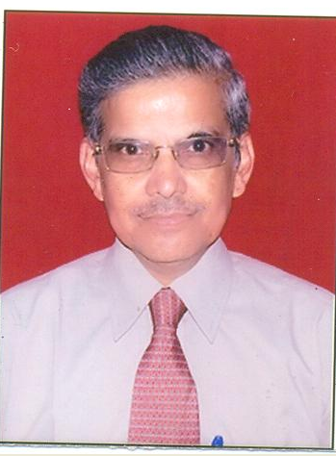

To,
The Head (HR),
Post applied for | BRANCH MANAGER/ADMIN /HR/BANKING &ACCOUNTS
Business stream | RETIRED/ VRS BANKER

Sl. No. | Items | Details
 | Name of the Applicant | PADAM CHAND GUPTA
 | Father’s/ Husband Name | LATE SH. GOPAL DASS GUPTA
 | Date of Birth | 04/04/1959
 | Category | GENERAL
 | Gender | MALE
 | Nationality | INDIAN
 | Address For Correspondence | 384, B-5 , SECTOR-8,  ROHINI  DELHI 110085
 | Permanent Address | 2/20, SETH GALI,  AGRA 282003
 | Telephone Nos with STD code & Mobile No. | 011-27948472  9810803568
 | Email id | Padamchand.gupta@yahoo.com

11.Educational Qualifications (Graduation onwards)

Sl. | Degree | University / Institution | Year of passing | %age obtained
1 | B.Sc | AGRA UNIVERSITY | 1979 | 45
2 | LL.B | AGRA UNIVERSITY | 1982 | 53
- Additional Qualifications (if any),

- Work Experience

Sl | Organization | Designation | Period |  | Responsibilities | Reporting to
Sl | Organization | Designation | From | To | Responsibilities | Reporting to
1 | STATE BANK OF BIKANER & JAIPUR | MANAGER | 1/8/1984 | 17/11/1996 | GENERAL BANKING,  CORPORATE FINANCE,  FOREIGN EXCHANGE,  SINCE AUG 1990 POSTED AT LARGE BRANCH TILL 17/11/1996 | AGM/  CM
2 | BANK OF PUNJAB LIMITED | ASST. VICE  PRESIDENT (AVP) | 18/11/96 | 17/11/2004 | AT FOREX TREASURY BACK OFFICE OPRATIONS | V.P/  SVP
3 | BHARAT  OVERSEAS  BANK | SENIOR  MANAGER | 18/11/2004 | 31/07/2005 | CENTRALISED FOREX TREASURY HEAD (NORTH) | CIRCLE  HEAD
4  5 | SHRI LAL MAHAL LIMITED  PARK HOSPITAL,  PASCHIM VIHAR,DELHI | TREASURY  MANAGER/  COMPANY  SECRETARY  ACCOUNTS & FINANCE | 01/08/2005  08/05/10 | 07/05/2008  11/07/2011 | BANK FOREX  MGMT/COMPANY SECRETARIAL  INCHARGE  FINANCE | ED/M.D.  ED/MD

13. Last place of working

Name of the Organization | Designation | Working since | Responsibilities | REPORTING TO
SERIOUS FRAUDS INVESTIGATION OFFICE, MINISTRY OF CORPORATE AFFAIRS , GOVT OF INDIA | CONSULTANTS  (BANKING) | JULY ,  2011 | INVESTIGATION OF BANKING FRAUDS OF CORPORATE LOANS/AUDIT TRAIL OF TRANSACTIONS | THE DIRECTOR  (SFIO)

16. Significant achievements:

My achievement in Financial Sector is that I have got diversified exposures based upon the confidence reposed upon me by my bosses & I have performed well having diversified exposure in areas of Administration /Legal/corporate finance & Audit/project appraisal / advisory in issue management/PE financing & overall is that I have developed a good Drafting Skill & understanding of Banking /Contract related legal aspects.
I hereby declare that the above information is true and correct to the best of my knowledge. I understand that my candidature will be cancelled, if the information is found to be false or incorrect or my application is incomplete.
Place: Delhi
Date: 13th March, 2015 Signature: 

