COL.KRISHN KUMAR RAI (Retd.)
Contact: 09968070920, 09415037923
E-Mail: krishn58@outlook.com

An accomplished professional with a dynamic career in Hospital Administration / Logistics / Supply Chain Management with an organization of repute in Healthcare, preferably in Delhi & NCR

PROFILE SUMMARY

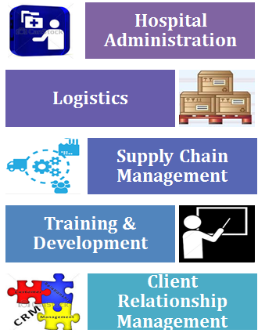
- An accomplished Army Professional with XXVI years of experience in Hospital Administration, Service Delivery, Logistics, Supply Chain Management, Training & Development, HR Operations, Client Relationship Management and People Management
- Extensive experience in managing operations of large armed groups with demonstrated leadership qualities and organizational skills
- Skilled in directing development and implementation of plans, operations & programs within assigned service units
- Resourceful in handling day to day activities in co-ordination with internal / external departments for ensuring smooth business operations
- Strong ability to master a situation quickly; highly knowledgeable in a wide variety of professional disciplines and an expert at organizing & directing turnaround situations
- Highly result-oriented, motivated and dynamic manager of change with a flair for conceptualizing, developing and implementing innovative practices for organizational improvement
- A strategic planner with extensive experience in managing operations of large armed groups with demonstrated leadership qualities & organizational skills during the tenure

Leadership: Driving the organizational mission through employees & supports motivation and engagement of employees in organization.
Strategic Contributor: Directing business in new growth areas by motivating people to perform beyond their normal past demonstrated skills / levels.
Management: Overseeing operations of the organization, implementing plans & managing resources.

ORGANIZATIONAL EXPERIENCE

Apr’88 – May’14; Indian Army as Colonel
I joined Indian Army on 20 Apr, 1988 as Captain & taken premature retirement from service on 16 May 2014, so I could complete this course i.e. MBA (HCA), & I served various medical non-medical units in various capacities like Adjutant, second in command, officer inch of various departments & commanded Military Hospital.

Key Result Areas:
…
Hospital Administration
- Handling the hospital services and liaising with Corporates, Govt. Institutions & other Authorities; organizing the hospital in a scientific manner to facilitate the performance of various medical functions
- Providing high standards of nursing care to the personnel, members of other services and entitled civilians; coordinating activities with approved vendors, marketing & promoting compliance with regulatory guidelines

Supply Chain Management / Logistics Operations
- Developing and sustaining the existing network & effectively managing the supply chain, ensuring timely and cost effective deliverables
- Coordinating with transporters and other external agencies to achieve seamless and cost-effective movement of consignment, ensuring timely deliveries

Medical Operations
- Studying the patient's medical history, examining the patient & carrying out tests; using the results of tests and examinations to decide on treatment
- Carrying out certain procedures for diagnosis or care such as attaching life-supporting equipment; monitoring results of treatment, advising patients and / or their caregivers on health care programs

Training & Development
- Developing, managing and monitoring the performance of multi-skilled work force and conceptualizing need-based training programs for their overall career development
- Designing training modules; evaluating the effectiveness of training programs by constantly developing & implementing pre & post assessment tools

Highlights:
- I took part in ‘OP Rainbow’ in Sri Lanka in 2004, when tsunami struck the south eastern part of that country ,we provided medical aids to the needy people with the help of civil authority. For this work, Sri Lankan Govt. given appreciation letter & Chief of Army Staff given commendation Card.
- I took part in medical relief /aid to civil authority in difficult periods, & delivered our services to needy people.
- I have taken part in various recruitment drives at different part of country.
EDUCATION

M.B.A. (HCA) from Faculty of Management Studies, Delhi
Delhi University

D.H.H.M from IGNOU, New Delhi
IGNOU, 2012

M.B.B.S. from G.S.V.M Medical College, Kanpur
Kanpur, university, 1988

B.Sc. from Gorakhpur University, Gorakhpur

Gorakhpur,1979

PERSONAL DETAILS

Date of Birth: 10 Jan 1958
Permanent Address: House No. 201, Bhukant Vihar, AWHO Colony, Shaheed Path, Lucknow-226012
Present Address: A/301, Dwarka Dham Apartments, Plot No. 13, Dwarka- Sector 23, New Delhi-110077
Languages Known: English/ Hind

