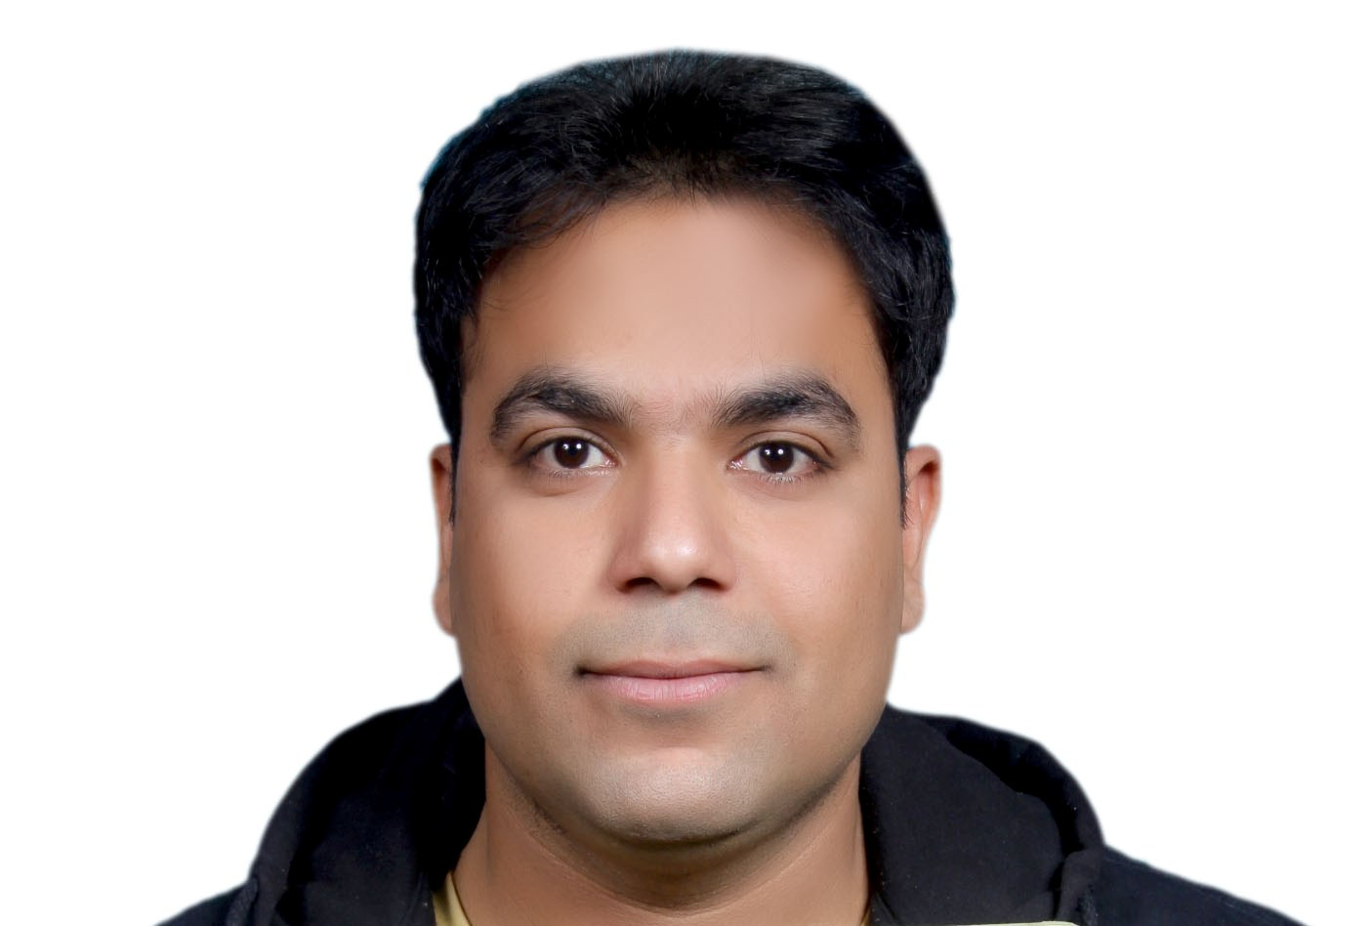
NAME- GAURAV KUMAR
FATHERNAME- RAMESH CHANDRA
MOTHERNAME- SARLA CHANDRA
DATE OF BIRTH- 05-02-1982
SEX- MALE
RELIGION- HINDU
MARITAL STATUS- UNMARRIED
QUALIFICATION- M.B.B.S.,D.CH.DNB Pediatrics
PERMANENT ADRESS- OPPOSITE BLOCK OFFICE,JANSATH,
MUZAFFARNAGAR,U.P

CURRENT ADRESS- c6b/168 Janakpuri New Delhi
110058

QUALIFICATION | YEAR OF PASSING | BOARD/UNI./COLLEGE | PERCENTAGE | ATTEMPT
HIGH-SCHOOL | 1996 | U.P.BOARD | 80% | SINGLE
INTERMEDIATE | 1998 | U.P.BOARD | 80.4% | SINGLE
M.B.B.S. | 2005 | L.L.R.M.MEDICAL COLLEGE,MEERUT | 60.03% | SINGLE
DIPLOMA IN CHILD HEALTH[D.CH.] | 2009 | K.G.M.U.,LUCKNOW | 57.33% | SINGLE
DNB pediatrics | 2014 | Mata chanan devi hospital janakpuri new delhi | Pass | Single

EXPERIENCE- SIX YEARS EXPERIENCE

CURRENTLY WORKING AS- AS S R in delhi govt hospital.

SPECIAL INTEREST IN- NEONATOLOGY AND INTENSIVE CARE.

PHONE NUMBER- 7503050111

EMAIL- dr_gaurav2009@rediffmail.com,
Expected ctc- 1.4 lacs per month

I HEREBY DECLARE THAT ABOVE MENTIONED INFORMATION IS TRUE ABOUT ME

GAURAV KUMAR

