CURRICULUM VITAE
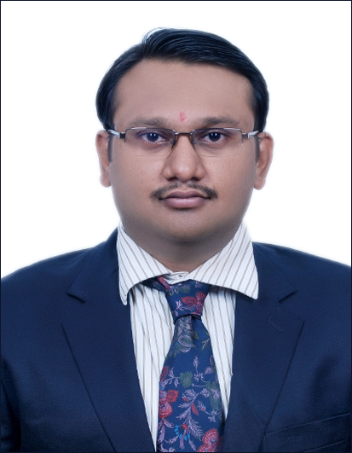
Name : Dr. Himanshu Gupta.
Father’s Name : Shri Banwari Lal Gupta.
Date of Birth : 12th December. 1982.
Place of Birth : Kanpur, India.
Nationality : Indian
Address : CHPL Dream Homes,
H-5, IIInd Floor, Smriti Nagar
Bhilai (Chhattisgarh) - 490020
Mobile : +91-8884168177 / +91 – 7024155031

ACADEMIC QUALIFICATIONS:
- MBBS Dec 2004, 1st attempt 1st division, MUHS Nashik.
- Post Graduate certificate course in Accident & Emergency care Dec 2006, Apollo Hospitals Educational & Research, Hyderabad, India
- MS (General Surgery) July 2011, 1st attempt, MUHS Nashik.
- Fellowship in Minimal Access Surgery (FMAS) Nov 2013, Trivandrum, India.
- Fellow of Indian Association of Gastro Endoscopic Surgeon (FIAGES) Dec 2013, Coimbatore, India.
- Fellowship In Surgical Gastro June 2014, Narayana Health Hospital, RGUHS Bangalore, Karnataka, India

DISSERTATION:
Diagnosis & Management of Fistula in Ano, June 2008 – Dec 2011.

PROFESSIONAL EXPERIENCE:
- House Officer in Surgery, N.K.P. Salve Institute of Medical Sciences & Research Centre, Nagpur, 11-02-2006 to 01-05-2008.
- Full time Resident Post-Graduate, N.K.P. Salve Institute of Medical Sciences & Research Centre, Nagpur 02-05-2008 to 01-05-2011.
- Senior Resident in Department of Surgery, N.K.P. Salve Institute of Medical Sciences & Research Centre, Nagpur 09-08-2011 to 18-07-2012.
- Fellowship in Surgical Gastroenterology, Narayana Health Hospitals, (Rajiv Gandhi University of Health Science- RGUHS) Bangalore, Karnataka July – 2012 to June – 2014.
- Senior Registrar in Department of Surgical Gastroenterology, Narayana Health Hospital Bangalore, Karnataka July 2014 – Feb 2015.
- Presently working in Apollo BSR Hospital, Bhilai (Chhattisgarh) as Consultant in General & Laparoscopic Surgery Department from Feb 2015 till date.

AWARDS & COMMENDATIONS:
- Awarded Commendation for Lecturer in NSS – Orientation Training Programme conducted on 19-01-2008 by MUHS, Nashik
- Awarded Commendation for working in Hemalkasa Surgical Camp 2008 organised by Rotary Club of Nagpur.

PROFESSIONAL AFFILIATIONS:
- Life Member, Association of Surgeons of India
- Life Member of Association of Minimal Access Surgeons of India
- Life Member of Indian Association of Gastrointestinal Endo Surgeons

ONGOING RESEARCHS:
- Study of Fournier Gangrene (Sept 2011 till date)
- Study of Efficacy of Ksharsutra in low fistula in ano (Sept 2011 till date)
- Role of Ksharsutra in Pilonidal sinus with multiple openings (Sept 2011 till date)

NATIONAL PRESENTATION:
- “PILONIDAL SINUS: IS KSHARSUTRA – A NEW MODALITY OF TREATMENT?” paper at ASICON 2010.

INTERNATIONAL PRESENTATION:
- KSHAR SUTRA (MEDICATED SETON) – EMERGING MODALITY IN MANAGEMENT OF FISTULA IN ANO‏. Oral presentation at IASGO 2012.
- LEFT SIDED BOCHDALEK HERNIA IN ADULT – AN UNUSUAL PRESENTATION: A CASE REPORT. Poster presentation at IASGO 2012.
- PRIMARY LUMBAR HERNIA – AN UNUSUAL PRESENTATION: A CASE REPORT. Poster presentation at IASGO 2012.
- PILONIDAL SINUS: IS KSHARSUTRA – A NEW MODALITY OF TREATMENT IN MODERN ERA. Video Olympiad presentation at IASGO 2012.
- LEFT SIDED BOCHDALEK HERNIA IN ADULT – AN UNUSUAL PRESENTATION: A CASE REPORT. Video Olympiad presentation at IASGO 2012.

Conference attended
NATIONAL:
- Asicon 2010
- Asicon 2011
- ICC 2011
INTERNATIONAL
- IASGO 2012
- WCC 2014
Workshops
- AMASI 2013
- IAGES 2013

Date : 17-06-2015
Place : Bhilai
Signature: himanshu gupta

