CURRICULUM VITAE
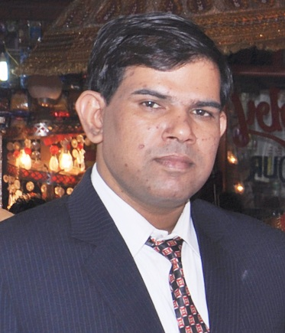

Dr. Banwari lal Bairwa
M.S., M.Ch. (Neurosurgery)
Father Name – Shri J.R. Bairwa
D.O.B – 18 August 1978

Residence address – 10/22 Old Rajendra Nager New Delhi 110060
Permanent address – Bhandaraze mode dhonya Dist. Dausa Rajasthan 303501
Contect No. – 9268247276, 8468914028
Email – blb_dr@yahoo.co.in

Qualification:-
M.B.B.S. – March 2002
- JLN Medical College Ajmer Rajasthan
- University of Rajasthan Jaipur Rajasthan
- Rajasthan medical council No. 021954 / 23 June 2003

M.S. (General Surgery) –
- October 2007
- S.P. Medical College Bikaner Rajasthan
- Rajasthan university of health science jaipur
- Rajasthan medical council No.008362 / 05 Feb 2008

ATLS - MAY 2015
- DR. RML HOSPITAL NEW DELHI 110001
- AMERICAN COLLEGE OF SURGEON
- ATLS ID – 617440

M.Ch. (Neurosurgery) –
- July 2015
- Post graduate institute of Medical Education and Research
- DR. RML HOSPITAL NEW DELHI 110001
- Delhi medical council No.38006 / 23 May 2008

Work experience :-

S.No | Subject | Designation | Institute | From | To | Total
1. | Gen. Surgery | S.R. | S.P.M.C. Bikaner | 01-01-08 | 15-06-08 | 6 ½ M
2. | Neurosurgery | S.R. | Lok Nayak Hospital  MAMC New Delhi | 18-06-08 | 17-06-11 | 3 Year
3. | Neurosurgery | S.R. | ,, ,, | 01-07-11 | 30-07-12 | 1 Year

Expertise in:-
Neurosurgery (Brain Tumour surgery, Spinal surgery, Vascular
Surgery, Paediatric Neurosurgery, Head and Spinal Trauma
Surgery)

DATE Signature
PLACE

