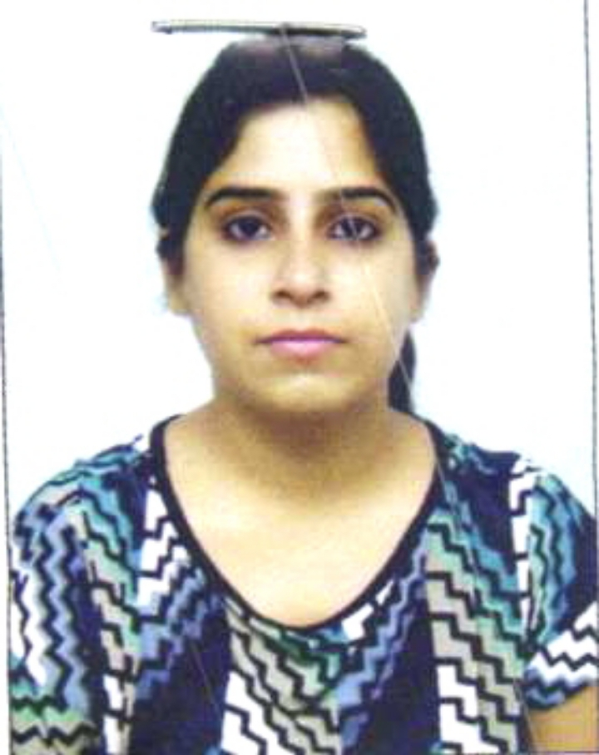

Tajinder Kaur

A-2/92, Ashirwad Appartment
Paschim Vihar
New Delhi-110063

Mob: +91 9654040690, 7838111816
Email id: kaurtanu88@yahoo.com

Objective

An enthusiastic person with excellent leadership skills, adaptability and a commitment to quality and Customer satisfaction while driving deliverables towards goals.

Strengths
- Exceptional ability to understand Customer's need, patience to teach and do the things repeatedly until desired output achieved.
- Always Eager to learn and let others learn about new process every time
- A strong sense of responsibility and commitment towards the assignments undertaken.
- Ability to adjust in changing work cultures and environments with ease.
- Ability to create good coordination and efficient co-operation among team members.
Working Experience
At present working in ACTION CANCER HOSPITAL (NABH Approved) (unit of SRI BALAJI ACTION MEDICAL INSTITUTE) as a Front Desk Executive from October 2012 to Till Now.
- Handling Registration and Admission process for OPD & IPD Patients and Reception area.
- Creating Discharge Summaries for Cancer patients and keeping all the records related to summaries.
- Check the arrangements for Tumor Board meetings and co-ordinate accordingly with the doctors and ensure meeting end up smoothly.
- Handle all work-load in Day-care independently and create approx 40 summaries in a Day.
- Handling inbound queries of clients and ensure it has been answered correctly.
- Arrange patients file and send it back to MRD on daily basis.
- Create reports on Daily basis related to Appointments, Medical Record Room.
Worked with ADFC (sister concern of HDFC Bank) as a Customer care executive from 24th Jan 2012 till 30th June’12

- Handling customer’s problem related to their A/c & other banking queries like FD, loan, current & Saving a/c etc
- Ensure satisfactory closure is done for their queries.
- Accountable to make leads for FD, loan, Current & Saving a/c, life insurance etc
- Providing the exact status to the customers for their registered cases.
- Need to take follow-up on the assigned cases.

Worked with Serco as a CCE from 14th June’10 till 14th June’11.

- Handling customer’s problem related to systems.
- Need to co-ordinate with Services centers regarding assigned cases.
- Need to take follow-up on the assigned cases.
- Providing the exact status to the customers for the registered cases.

Academic Qualification

- 12th passed from CBSE
- 10th passed from CBSE
- Graduate from Delhi university
- Pursuing MBA (4th SEM)

Personal Details

Address: A-2/92, Ashirwad Appartment, Paschim Vihar, New Delhi: 110063

Regards

Tajinder Kaur

