CURRICULAM VITAE 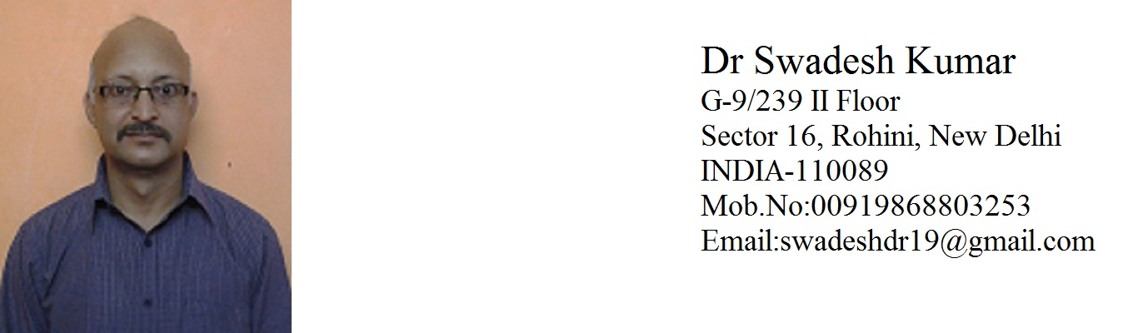

Qualification
March 2001 M.B.B.S, King George’s Medical College Lucknow UP INDIA
December 2008 PGDMCH Indira Gandhi National Open University Delhi INDIA
May 2015 MBA(HEALTH CARE SERVICES) Sikkim Manipal University, Manipal - INDIA
APPOINTMENT

Date | Position held | Hospital
12 Oct 2015 TO TILL DATE | Senior Resident in Paediatrics & Neonatology | Maharishi Valmiki Hospital, Pooth Khurd, Delhi, India.
20 Oct 2009 To 15 Aug 2015 G  (01-11-1430 to 30-10-1436 H) | Paediatric Resident ( Paediatric & Neonatology Dept.) | Samtah General Hospital, JAZAN, (M.O.H.)K.S.A.
02 Feb 2009 to 11 Aug 2009 | Senior Resident ( Casualty Department) | ESI Hospital, Sree Maa Anandmayee Marg Okhal,Phase I New Delhi 20 INDIA,INDIA
01 July 2008 to 31 Jan 2009 | Own Clinic | Own Private Clinic, New Delhi, India
July 2006 To June 2008 | Research officer  (Paediatric & Neonatology) | A.I.I.M.S. New Delhi, India
March 2005- July 2006 | Senior Research Fellow  (Paediatric & Neonatology) | A.I.I.M.S. New Delhi, India
Dec 2004-March 2005 | Junior Resident  (Surgery) | G.T.B. Hospital & U.C.M.S.New Delhi, India
Aug 2004-Dec 2004 | Junior Resident  (Psychiatry) | G.B. Pant Hospital New Delhi, India
Aug 2003-Aug 2004 | Junior Resident  (Paediatric & Neonatology) | Deen Dayal Upadhyay Hospital Hari Nagar New Delhi, India
Jan 2003-Aug 2003 | Resident Medical officer | Surya Laxmi Hospital Vikas Puri New Delhi, India
March 2001- March 2002 | Internship | Gandhi Memorial & Associated Hospital K.G.M.C Lukhnow , U.P. , India
.
.
CLINICAL EXPERIENCE : 12 Years 7 Months(Pediatrics & Neonatology)
- SAUDI NEONATAL RESUSCITAION PROGRAM (AAP)
- BLS ( SAUDI HEART ASSOCIATION)
- ADVANCED PEDIATRIC EMERGENCY COURSE
- Member of EMERGENCY MEDICINE ASSOCIATION, INDIA

EDUCATIONAL QUALIFICATION :

Yr. of Passing | Exam Passed | College/ Board | Marks Obtained | % Of Marks
May 2015 | MBA (Health Care Services) | SIKKIM MANIPAL UNIVERSITY | 3028/5000 | 60.56
Dec 2008 | PGDMCH(Post Graduate Diploma of Maternal & Child Health) | I.G.N.O.U. DELHI | 382/600 | 63.67
March 2001 | MBBS | K.G.M.C. LUCKNOW (U.P.) | 1907/3500 | 54.48

Permanent Address Dr Swadesh Kumar
Plot No-238, Kh No.68/8- G/F
Ambedkar Place, Baprola Vihar
Near Kheri Baba Mandir,
New Delhi- 110043, INDIA
Contact no.+919868803253,+911127850947

E-mail swadeshdr19@gmail.com,swadeshdr@hotmail.com

SKYPE I.D. s.kumar998

Nationality INDIAN

DOB 01-02-1976

Passport No Z3275734 (Valid upto 20-08-2025)

U.P. Medical Council No: 046229
DMC Registration No: 17890
MCI Registration No. 201(34)/2002-Regn./38726= No: 46229
SAUDI COMMISSION
FOR HEALTH SPECIALTIES: 10-G-M-0346993

Dr. Swadesh Kumar

