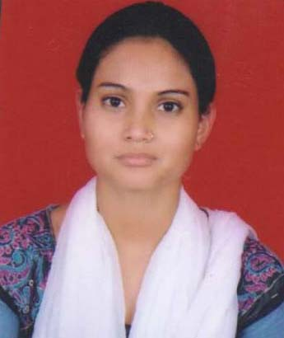

CURRICULAM VITAE

ANJALI

STREET NO. – 19, SUSHANT VIHAR (IBRAHIM PUR EXT.) DELHI – 110036

Email: anjaliiph@gmail.com  8860760124, 9968198560

OBJECTIVE

Looking forward to get associated with a hospital & laboratory where I can grow and make best use of my education knowledge and demonstrate a high commitment and motivation to achieve success.

PROFESSIONAL & EDUCATIONAL QUALIFICATOIN

- Passed 10th from CBSE Board in 2010 New Delhi.
- Passed 12th from CBSE Board in 2012 New Delhi.
- Pursuing graduation(3rd Year) from Delhi University.
- Diploma in Medical Lab Technology (DMLT) from Institute of Public Health & Hygiene, New Delhi with Grade ‘A’ in 2013.
- Six months training completed in SRL Laboratory with Fortis Hospital at Shalimar Bagh, Delhi from 24th June 2013 to 23rd December 2013.
- Presently working as a Lab Technician at Dr. Lal Path Labs from 20th Jan 2014.
- Know also about Computer basics & M.S. Word.

STRENGTHS

- Disciplined and well-organized in work habits.
- Flexible and fast learner with cross platform activities.
- Know about all departments in laboratory and also know about Histopathology Department.

PERSONAL INFORMATION

Father’s name : Sh. Ramesh Pokhriyal

Date of birth : 30th May 1995

Gender : Female

Nationality : Indian

Religion : Hindu

Languages known : English, Hindi

Hobbies : Listening Music & Book Reading

Place: Delhi

Date:

(ANJALI)

