GAURAV SHARMA
Mobile : 7037525220 , 09927936000, 7500476000 ~ E-Mail: grvrsh@rediffmail.com

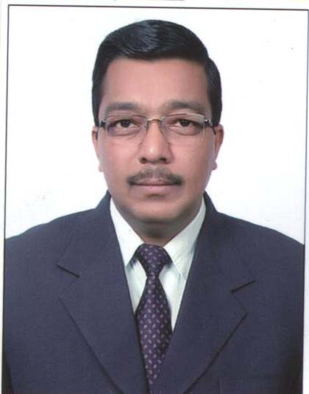

Dated: 22/12/2015

Respected SIR

This is in reference to your Adv in Times of India dt. 09TH DEC. 2015 . Please find attached my Resume for the post of MEDICAL DIRECTOR I'm particularly interested in this opening / position, which relates strongly to my nearly 25 years of experience in hospitality industry.

=> 10 years rich experience in PHARMA SALES , LEFT AS REGIONAL SALES MANAGER
=> 15 YEARS RICH EXPERIENCE IN PATHOLOGY INDUSTRY.

. A professional with a vision and commitment to independently handle full- fledged operations.
With a mature and sincere thinker. Having work exposure of ENTIRE NORTH INDIA.

- With my strong experience I believe I meet all the essential criteria of the position. Highlights of experience and demonstrated talent I would bring to your organisation

I appreciate your taking the time to review my credentials and experience. .

Thanking you.

Sincerely,
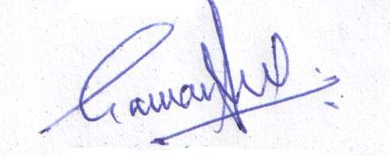
Gaurav Sharma

Enclosure: Resume

GAURAV SHARMA
Mobile: 7037525220 ,09927936000, 9690873328 ~ E-Mail: grvrsh@rediffmail.com

Seeking senior managerial assignment with an organization of high reputed hospital industry

PROFESSIONAL SYNOPSIS
- Nearly 25 years of rich & comprehensive experience Sales & Marketing, Business Development, Channel Management and Team Management .
- Adept in managing business operations and expertise in determining company’s mission & strategic direction as conveyed through policies and corporate objectives.
- Adroit in handling business development, identifying & developing new markets, guiding lead generation and client retention activities.
- Extensive experience in business & market development, product positioning and channel expansion.
- Ability to support & sustain a positive work environment that fosters team performance with strong communication and relationship management skills.

CORE COMPETENCIES
- Business Development: Developing new markets for promoting the products; conducting competitor analysis by keeping abreast of market trends & competitor to achieve market share metrics. Conceptualizing and implementing sales promotional activities as a part of brand building and market development effort.

- Relationship Management: Building & strengthening relationships with Opinion Leaders, thereby ensuring high customer satisfaction by providing them with complete product support.

- Team Management: Leading & monitoring the performance of team members to ensure efficiency in sales operations, meeting of individual and group targets. Creating & sustaining a dynamic environment to foster development opportunities and motivates performance amongst team members

- Sales & Marketing: Driving sales initiatives & achieving desired targets with overall responsibility of exploring marketing avenues to build consumer preference and driving volumes. Implementing marketing strategies for promoting various products as per the plans of company.

CAREER CONTOUR
DR. LAL PATH LABS PVT. LTD Business Head SINCE 2000

Highlights
- Played a pivotal role in handling the successful franchisee operations.
- Steered efforts for initiating the business from scratch to handsome sales.
- Significantly handled all new Products, facilitated the launch of products to DR’s and clients.
- Actively involved in improving the customer satisfaction level by coordinating the CRMs and Doctor Meet Camps.

M/s. Perch Laboratories Ltd REGIONAL SALES MANAGER HQ-NEW DELHI 1998 – 2000

Highlights
- Effectively handled the area of operations including Delhi, Haryana, Punjab, UP, Uttranchal and J&K.
- Valued as the Youngest Regional Sales Manager in industry during that time.
- Steered efforts for improving systems and controls at various functional levels in Perch Laboratories Ltd.
- Significantly contributed to marked improvement in customer service levels resulting into improved performance levels.
- Dexterously led a team size of 32 including 26 PSRs, 5 Area Managers and 1 Institutional Sales Manager.
- Successfully guided the team which remained No. 1 Contributor to the total business of the division.
- Steered efforts for boosting & maintaining the business volume and growth of the team which remained no. 1 nationally.

PRECEDING TASKS
Wallace Pharma (Indi Pharma Ltd.), District Manager HQ-NEW DELHI 1997 – 1998
Unique Pharma Limited, Medical Representative HQ-GHAZIABAD 1992 – 1997
Glaxo India Ltd., Medical Representative HQ- MIRZAPUR 1990 – 1992

SCHOLASTICS
- B.Sc. from Meerut University in 1988.

TECHNICAL QUALIFICATION
- Diploma in Computer Software from National Council for Vocational Training, New Delhi in 1989.

IT Skills : Well versed with MS - Office and Computer Applications.
PERSONAL DOSSIER
Date of Birth: 9th September, 1968
Address: H. No. 61 A, Near Dr. Indira Bhargava Nursing Home , Gill Colony, SAHARANPUR
247001 , UTTAR PRADESH , INDIA
Languages Known : English and Hindi
Expected CTC : Negotiable.

READY TO RELOCATE .

GAURAV SHARMA
MOB : 7037525220 ,09927936000, 9690873328

