Homoeopathic Consultant/ Research Officer/ Administration Manager/ H R Manager/ Executive Manager.

Education: 9yrs---BHMS, MD(Homoeopathy)
Experience:9yrs.
Relocation:Yes, Internationally.
Industry Experience/ Clinical Experience: 9yrs---Homoeopathic Consultant.
Career Objective:
Objective---My objective is to apply the experience I have gained in Homoeopathy & Homoeopathic treatment for various diseases like Skin, Respiratory, Joint Pains, Haemorrhoides(piles), Kidney-Stone, Urinary tract infections, Tonsillitis, Sore Throat, Disorders of Menstruation, Ovarian cyst, etc., for safe and effective treatment.

Professional Experience: Nine years(9yrs.) in Organizations/ Hospitals/ Construction company- have provided me a sound knowledge of Homoeopathic treatment for vaious diseases with Homoeopathic medicines. Working with team and team management with Multi-Cultural and Multi- National atmosphere.

Education
Education & Qualification: MD(Homoeopathy) with Specialization in Organon of Medicine from India---Rajiv Gandhi University of Health Sciences, Bangalore, Karnataka, India.
Professionally qualified in Homoeopathic Medicine and Clinical Medicine from India.
IT Skills: Proficient with Internet, Microsoft word,Microsoft Excel, Power Point.

Additional Information:
Present Address: Dr.Mani
C/O. Dr.Y.V.Patil(Professor),
B1-101, First floor,
Shalini Vishwa Apartments,
Datta Nagar,
Pune,
Maharashtra,India.
Phone Number: +91-9533105600
E-mail ID: mani_bhaskar23@yahoo.co.in
Nationality: Indian
Languages Known: English,Hindi, Tamil, Marathi and other languages.

It is hereby, declare that all the above information given by me is true and correct to the best of my knowledge.
Dr.I.N.Mani

Photograph
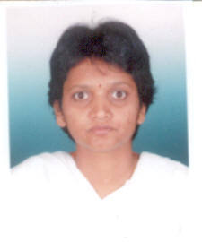
Dr.Mani

