Dr. Monisha
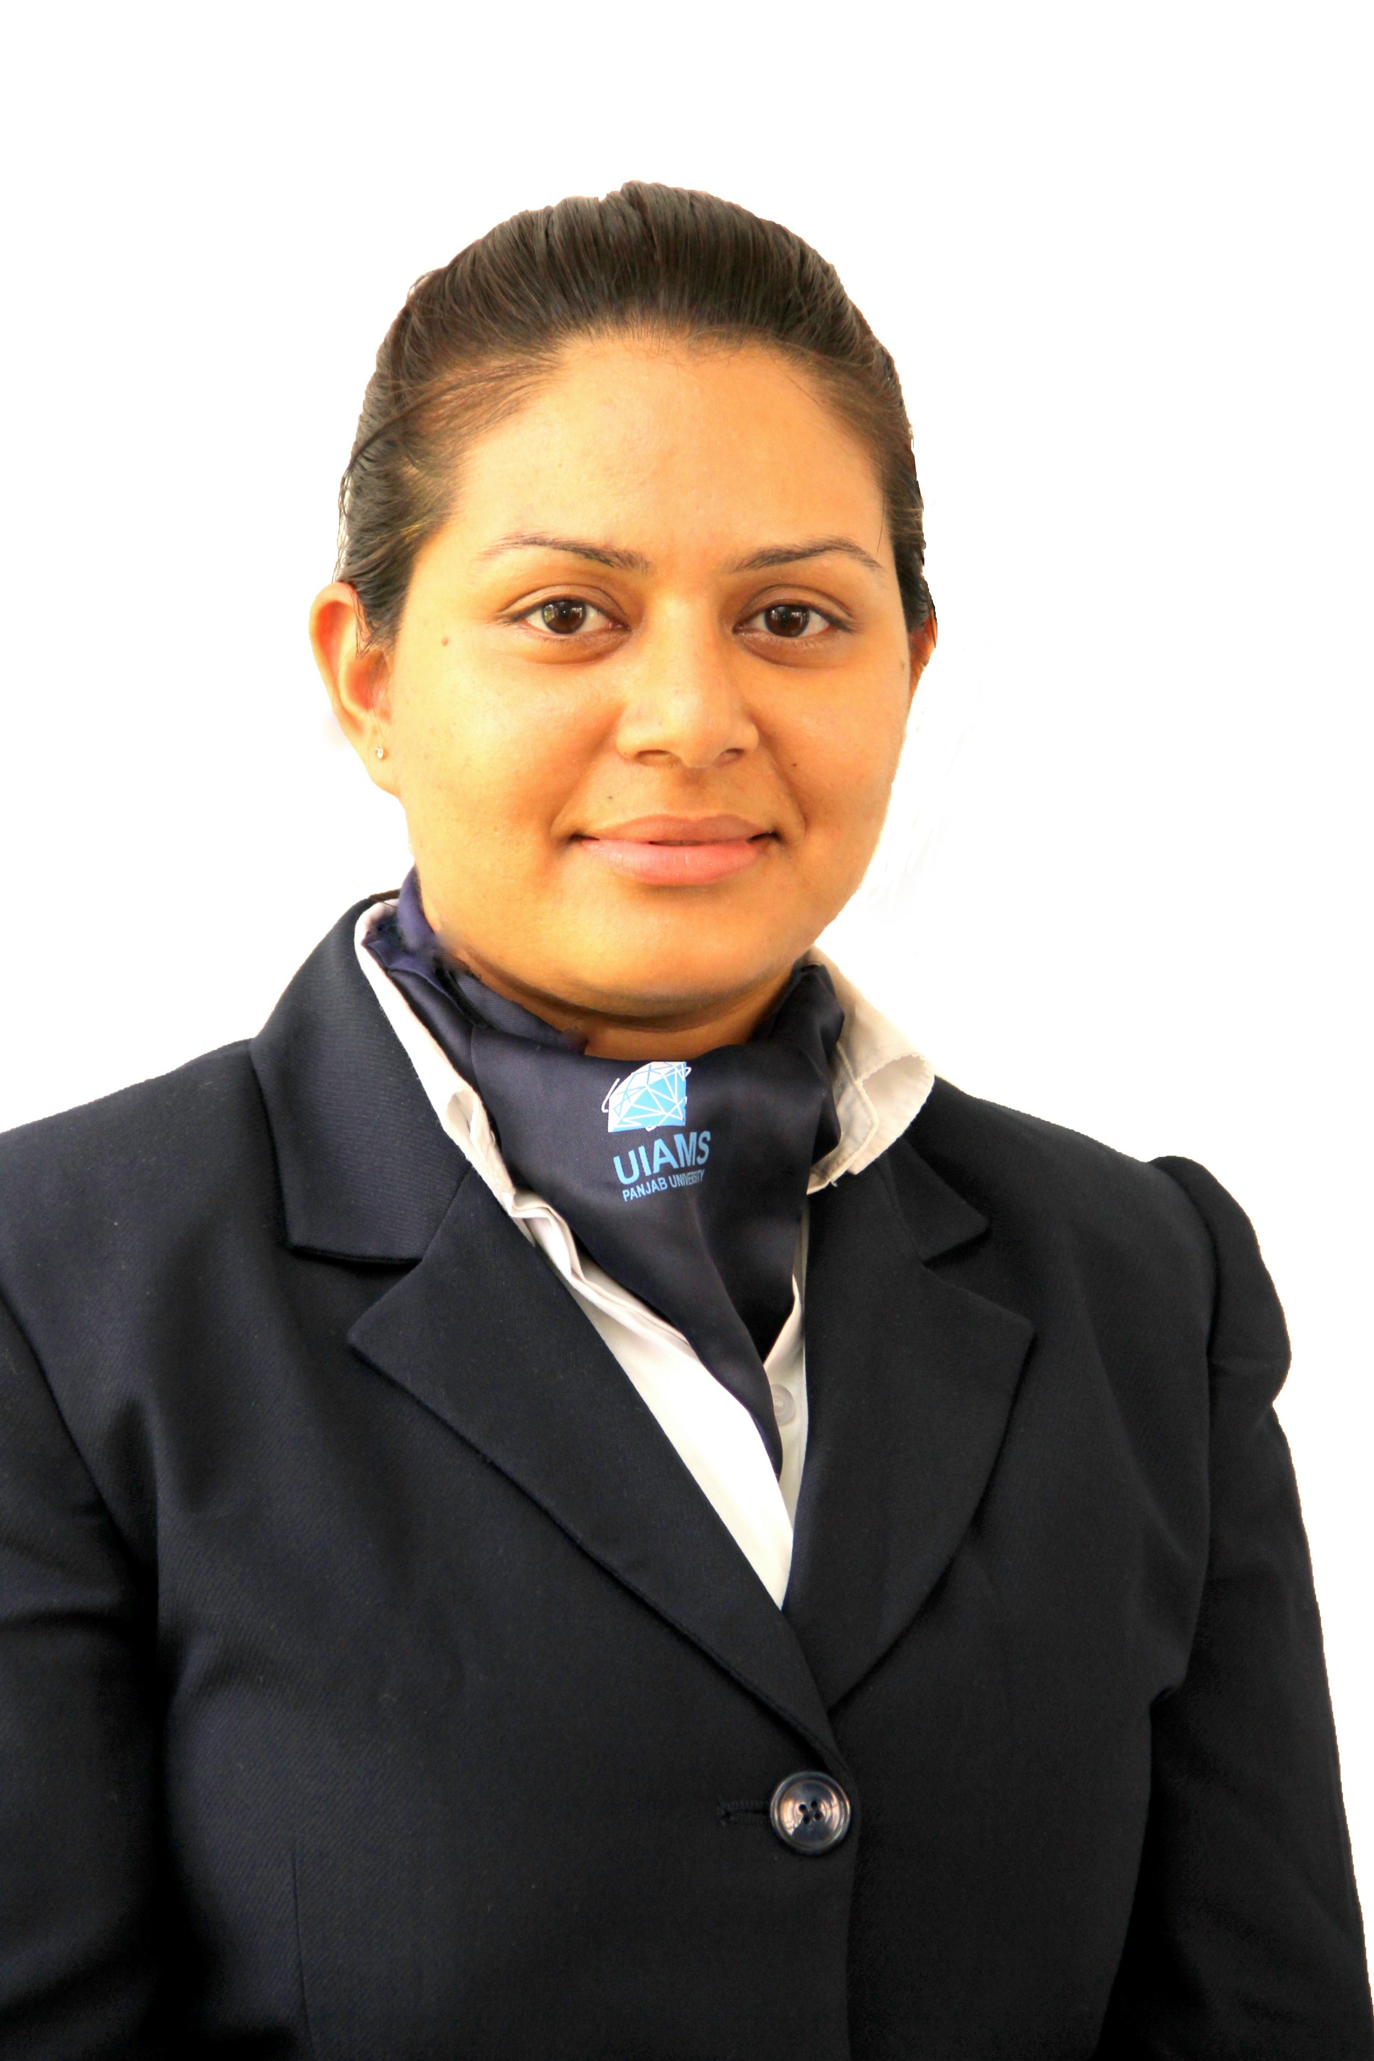

Address For Communication:
Contact: +91 9915492820 (M)
E-mail: drmishel2012@gmail.com

Career Objective:

A position in which my skill ability and education will be utilized for the best benefit of the organization.

Educational Qualifications:

Course | Institute | University/ Board | Year
M.B.A.  In  Hospital Management | University Institute of  Applied Management Sciences  (Location, State)  Specialization  Major Operations  Minor Human Resources | Punjab University, Chandigarh | 2012-2014
Bachelor of  Dental Surgery (B.D.S.) | National Dental College, Derabassi (Punjab) | B.F.U.H.S | 2005- 2011
12th Standard  10TH Standard | Kendriya Vidyalaya  Suranussi  Jalandhar  Kendriya Vidyalaya  Suranussi  Jalandhar | C.B.S.E  C.B.S.E | 2004  2002

Client Handled
- Employee State Insurance Cooperation(ESI).
- Central Government Health Scheme (CGHS)
- Ex-Servicemen Contributory Health Scheme(ECHS).
- Semi- Conductor laboratory (SCL)
- All insurance company patients

Training:-
- NABH
- Fire and safety
- Basic life support training

WORK EXPERIENCE:

- 25th Jan2015 – Till Now , Working as a Corporate Billing Manager in Indus Hospital Mohali.
- 25th August 2014- 25th jan, 2015 Worked As A Programme Executive In Cardio Thoracic Vascular Surgery Department Of Max Superspeciality Hospital Mohali 6 Phase
- 15th Oct2011 -15th June, 2012 : Worked As Dental Surgeon In Jatana Dental, 7 Phase Mohali.
- 1st July 2011 – 14th Oct.2011 : Worked As Dental Surgeon At Saroa Dental Clinic, Jalandhar

Internship/Training during the graduation:

Organization | National Dental College , Derabassi Mohali.
Internship | 1.07.2010 TO 30.06.2011 (Complete 1 Year)
Project title | Awareness on Tobacco and other Oral habits.  Street show on Oral habits, Derabassi 6 march 2011.

Internship / Training during Postgraduation:

Organization | M. S Ramaiah Medical College and Hospital, Bengaluru
Internship | 10.05.2013 to 10.07.2013 (complete 2months)
Project title | Absenteeism among Nurses because of stress

Final Year Project during Postgraduation;

Organization | University Institute of Applied Management Sciences , Panjab University
Project title | Hospital efficiency in Emergency Department

ROLES AND RESPONSIBILITY

- Handling Team of 9 persons under Me.
- Appointing new team members and derive work from them
- Deals with all the Corporate Company, T.P.A & Several Insurances Regarding Patient Health Care. (Intimations, approvals, looking after queries generated by insurance companies , handling of documents along with patient id and company insurance card, counseling of the patients regarding there copayments and nonpayables to the hospitals, sending of documents through courier to the respective insurance companies)
- Arrange Meeting with Marketing Head and there Team on monthly basis to discuss any shortcomings or updations in company rate list or if there is some new empanelment .
- Presiding officer of Medical record department. (Regular audit and checking of MRD indicators on regular basis)
- Takes lecture in various companies on medical topics (sunpharma, colgate, Schools)
- Organize and visits for Medical/ Dental camps in various school and department of punjab university.
- Solves patient queries regarding there treatment w.r.t Billing.
- Admissions and discharge of cardiac patient.
- Allotments of beds.
- Coordinates with Patientand there Attendants which includes Counseling, Billing (Packages), Investigation, discharge instructions .
- Handling Day to Day Patient's transfer’s in IPD Wards.
- Arranging cardiac rehabilitation programme separately for pre op and post op cardiac patients and there attendents every day .
- Managing the patient rush in consultant OPD.
- Keeping the records of the patient’s transfers within ICU & Wards.
- Co-odinating with several doctor's at a time.
- Handled the Responsibilities of getting the duty done from Housekeeping & GDA Supervisors in CTVS DEPTT.
- Making all the required Appointments of patient and scheduling them.

OTHER SKILLS:

- Knowledge of MS-OFFICE (MS-POWER-POINT, MS-EXCEL, MS-WORD)
- Good Communication Skills (Persuading, influencing and Negotiation skills)
- Effective time management skills
- Leadership skills

EXTRA-CURRICULAR ACTIVITIES:

- Worked as Placement representative of Hospital management at UIAMS during 2012
- Participated in a dance performance on the behalf of dance world, sector-17 in
Motiram school, Chandigarh on 25th e.g. 2012
- Participated and worked voluntarily in a management development program in M.S Ramaiah medical college and hospital in Bangalore, Karnataka in 27th to 29th june2013
- In-charge for women's wing (south campus) in Panjab university in 2013
- Participated in 18th Pradanya international conference on healthcare India: opportunities, challenges and innovations Oct 3 to 6 oct2013 IHMR Jaipur
- Voluntarily worked and participated in the noble cause awake and be the change program organized by ears 16th to 23rd November 2013 Chandigarh.
- Participated in an event operational efficiency as a tool to improve hospital profitability held on Nov 9th , 2013 Chitkara university, Punjab
- Attended a publishing connect workshop organized by AC Joshi library Punjab university in collaboration with Elsevier on 26th Nov 2013.
- Attended and participated training session on work life balance and women’s wellness organized by Safety Circle Chandigarh 26 to 28 Feb 2014.
- Won basket ball championship in UIAMS Ranbhumi 2014.
- Worked as a class representative of Hospital management, entire academic years in UIAMS.
- Worked as a Programme Executive in Max Super Speciality Hospital Mohali
- Working as a Coorporate Billing Manager(H.O.D) and Training Officer at Indus healthcare.
- Participated as a Sponsor in International Summit On Medical Value Travel Oct 5th7th, 2015 Pragati Maidan, New Delhi India.

Hobbies: Basket Ball, Dancing, Travelling

Personal information:

Date of Birth | : 3rd Feb,1987
Father’s Name | : Mr. Raj Kumar
Mother’s Name  Language known | : Mrs. Nirmala  : English, Hindi, Punjabi(MT)

Declaration:-

I hereby declare that the information furnished above is true to the best of my knowledge and belief.

Place: Chandigarh Dr. Monisha

