RESUME

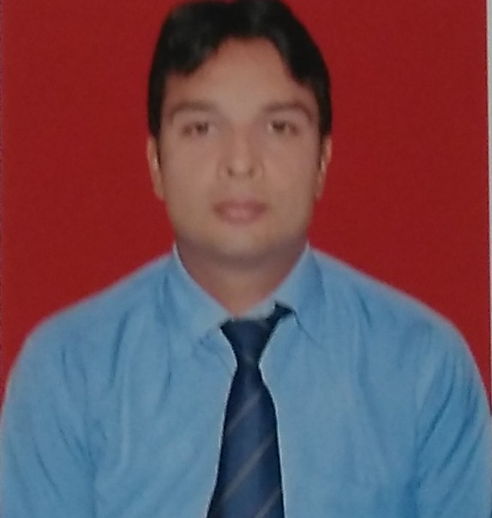
PRAVEEN KUMAR SHARMA
Address: RZF- 712/A
Street No – 1, Raj Nagar Part II
Palam Colony, New Delhi - 110075
Mob # +91 9999878830
Res # +91 8750355017
E–mail: - sharmapraveen@outlook.in
E- mail:- praveensharma@minister.com

Career Objectives

Seeking a challenging and exciting career in the field to the best of my abilities and with complete dedication and perseverance. The main objectives of my life have always been sincerity. I also believe in building good and healthy relations with people.

JOB PROFILE

Presently working with : CLIPS INDIA PVT. LTD
(Export/Real Estate Co.)

Designation : EXECUTIVE SECERETARY to MANAGING DIRECTOR

Duration : 28th JAN 2016 to Present

JOB PROFILE

Presently working with : GIZ - Deutsche Gesellschaft für Internationale Zussammenarbeit
(Non-Profit Organization)

Designation : FRONT OFFICE EXECUTIVE

Duration : 22nd April 2015 to 18th Jan 2016 (CONTRACT)

On 3rd Party Payroll : Discreet India Management Services Pvt. Ltd

JOB PROFILE

Previous Company : Manroland Sheetfed India Pvt. ltd
(MNC- German Based)

Designation : ADMINISTRATION EXECUTIVE

Duration : 16th May 2009 to 18st April 2015 (5 years 11 Months)

JOB RESPONSIBILITY
- Vendor Management
- Housekeeping Management
- Security Management.
- Petty Cash Management
- Tour & Travel - Hotel Booking/Air -Train Booking
- Stock & Stationary Record
- Office Maintenance
- Making Purchase Order
- Bill Submit like Telephone, Electricity, Internet, Credit Card etc.
- Bank Work like Cheque Deposit, Cash Withdrawn etc.
- Canteen Hygiene
- Maintenance of Office Cars/Booking of Vehicles
- Handling renewal of the Insurance of the company assets and others (cars and others) and for the better plans for the future.
- AMC’s
- Manage DG Set’s, AC’s, Electrical work
- Distribution of Printing and Statutory compliances
- Keeping All the Maintenance Reports/Records of the office
- Leave Records of the employees on the payroll software of the company.
- Generating the salary slips on payroll software of the company.
- Daily Reporting to the Director.
- Assisting them in their personal and official work.
- Maintaining all records of bills of the office and there timely payments.
- Maintaining attendance and salaries of Drivers/office boys.
- Maintaining all records of the employees.
- New Joining Formalities/ Induction
- Maintaining time (attendance) from internal attendance system – HRMS
- Work on Job Portal And Selecting candidate as per required profile
- Dealing With HR Manager of the company regarding their need

JOB PROFILE

Previous Company : HONDA MOTORCYCLE & SCOOTER INDIA Pvt. Ltd.

Designation : ADMINISTRATION ASSISTANT

Duration : April 2008 to March 2009
(on 3rd Party Payroll- 1year contract)

Professional Qualification

Diploma in COMPUTER APPLICATION from F-TEC.

Fundamental Ms-Dos, Win98, Ms-Office & Internet & Scanning.

Academic Qualification

- 10th Passed from CBSE Board
- 12th Passed from NIOS
- B.A from Delhi University

Personal Profile

Gender : Male
Date of Birth : 29 Jan 1988
Father‘s Name : Shri NAWAL KISHOR SHARMA
Nationality : Indian
Martial Status : Married
Language Known : English & Hindi

Other Interest

Sports specially Taekwondo. Participated in National Championship and won Gold Medal three times.
Listening to Music, Net Surfing and Traveling.

Place: New Delhi (PRAVEEN KUMAR SHARMA)

