CURRICULAM VIATE

To attain a challenging and rewarding carrier in
dynamic business environment where my skills and
diverse abilities can be used effectively.

- 10th Pass From B.S.E.R in Year 2002-- 46.50%
- 12th Pass From B.S.E.R in Year 2004 – 52.62%
- B.sc(N) 1st Year Passed From INSSR Gwalior(Mp) in year 2005.—62.00%
- B.sc(N) 2nd year passed from INSSR Gwalior(Mp) in year 2006.—60.20%
- B.sc(N) 3rd year passed from INSSR Gwalior(Mp) in year 2007.—63.83%
- B.sc(N) 4th year passed from INSSR Gwalior(Mp) in year 2008—67.50%

- As a Nursing tutor and clinical instructor - 7 year

- Work in :-
1. Life line hospital & Dr. Harish nursing school, alwar

2.Shree Nrashing college of nurshing bidyari bayana R.B.M Hospital bharatpur.

- Positive attitude and believe in relationship building, analytical and conceptual thinking, Effective communication and Resolving issues and decision making, Responsible, confident, Reliable. Hard Working And achievement-Oriented Coperative.

Date ……….
Place ……….

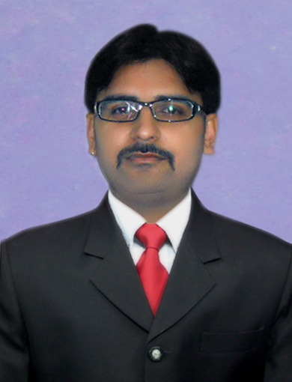

RAHUL DEV SONI

Address :

Rahul dev Soni
s/o Sh. Govind Prasad Soni
Uparla Bazar, Bhusawar
Disst.- Bharatpur (Raj.) 321406
Mobile No. : – 7665238585
9414943925
8104148388
Email ID – rahuldevsoni@gmail.com

Personal Details :

Date of Birth : 09september 1987

Father’s Name : Govind Prasad Soni

Nationality : Indian

Marrital Status : married

Gender : Male

Languages : Hindi & English

Hobbies : Reading Books,
Listening Music,
Playing Cricket:

Objective :

Acadmic Qualification :

Work Experience :

- Strength

Rahul dev soni

