CURRICULUM VITAE

HIMANSHU 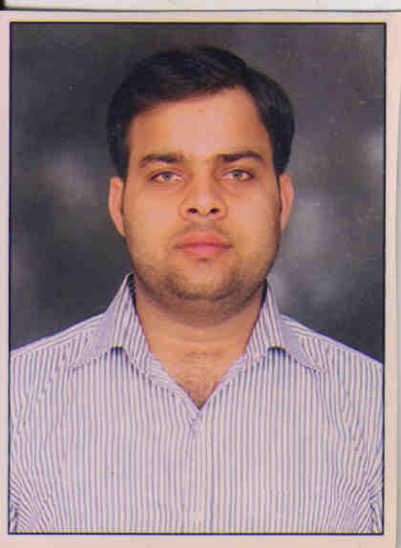

H.NO.-1524 Jawahar Colony, Faridabad
HARYANA-121001
Mobile No.: +91-9818436903
E-mail: anujverma1990a@gmail.com

Objective:
To work in a competitive and challenging environment that would facilitate the maximum utilization and application of my skills and expertise in making a positive difference to the organization.

Work Experience:

Metro Multispeciality Hospital, Faridabad

Sr. Billing Executive in International Marketing from 2015 to 2016.

Billing Executive IPD & International Marketing from 2012 to 2015

Front office executive from 2011 to 2012

Previous Experience:

Sarvodaya Hospital, Faridabad (2010-2011)

Role and Responsibility:
  - Replying to clinical queries after consultation with doctors to the patients.
  - Handling patient billing both international as well domestic.
  - Handling queries and receiving calls with regards to all the patients and coordinating with all the concerned departments for the same.
  - To implement and prepare estimates/packages for the patients .
  - To maintain an update of query database on daily basis.
  - Coordinating with interpreters regarding patient dealing & financial counseling.
  - Admission and Discharge process/formality of patients.
  - Daily updation of the feedback of the international patients.
  - Manage appointments, facilitation of investigation and collection of reports and the administration work.
  - Transport Management (Pick & drop).
  - Cash Management.
  - Meet with the patients on daily basis and resolve the complaints.
  - Daily reporting to our seniors.

Educational Qualification:
- Pursuing MBA in Banking and Finance from Symbiosis
- B.com. from CMJ University.
- 12th pass from HBSE
- 10th pass from HBSE

Computer Skills:
- Operating System : Windows-7
- Data base : MS-Office, Excel.
- Data Entry Speed : 25WPM(English)
- Software worked on : Akhil HIS, Administrator plus

Strengths:
- Strong analytical and logical skills.
- A very good team player with good interpersonal skills.
- Self confidence, positive attitude and optimistic, friendly and cooperative.
- Proactive nature and self-driven.
- A keen and fast learner.

Personal Details:

- Date of Birth : 19 April,1990
- Father' Name : Mr. Chander Bose Verma
- Marital Status : Single
- Languages Known : English, Hindi & Punjabi
- Hobbies : Net surfing, music, dancing and roaming with
Friends.

Date:

Place: Himanshu

