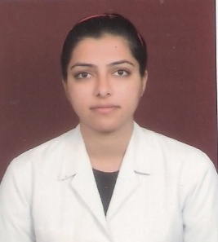
Dr. Aditi Yadav
3, NDMC Type - V Duplex Flats,
Rajesh Pilot Lane, Rajesh Pilot Road,
Near Prithviraj Road New Delhi -110003
09899799500, 09999919500
Email ID:dr.aditiyadav006@gmail.com

CAREER OBECTIVE
As a hard working individual, seeking an opportunity to learn & utilize my skills in the industry to achieve growth for the organization being innovative & to apply 3D’s:- Determination, Dedication & Discipline with Punctuality.

I’m looking for a job opportunity in Hospital Administration.

EDUCATION
Ram Manohar Lohia Hospital, Study Centre New Delhi

Post Graduate Diploma in Hospital & Health Management February 2015

I.T.S. CDSR, Muradnagar Ghaziabad
B.D.S April 2011

Navyug School, Lodhi Road New Delhi

S.S.C 2004

Queen Mary’s School New Delhi

H.S.C 2002

EXPERIENCE
- April1, 2011 to March 31, 2012 Internship at I.T.S. CDSR, Muradnagar.
- April1 2012 to March 31, 2013 Honorary Internship at Dental Department of Dr. Hedgewar Arogya Sansthan, Karkardooma, Delhi.
- From Aril 2013 to June 2014 ,Worked at Dental Department of Guru Nanak Charitable Polyclinic (Regd.), Sujan Singh Park, New Delhi 11003
- Currently assisting Dr. Amrish Kumar Yadav and managing the clinical work.

PERSONAL DETAILS
- Date of birth : 26th August 1986
- Father’s Name: Dr. Amrish Kumar Yadav
- Father’s Occupation: Doctor , Private Practice (Clinic)
- Mother’s Name: Dr. (Mrs.) Sadhna Yadav
- Mother’s Occupation: Doctor , Chief Medical Officer (N.D.M.C)
- Marital Status: Married
- Sex: Female
- Nationality: Indian

LANGUAGE SKILLS
- Languages Speak Write Read
- Hindi Excellent Excellent Excellent
- English Excellent Excellent Excellent

REFERENCES
Will be made available upon request.

DECLARATION
I solemnly declare that the above information is true and correct to the best of my knowledge. I understand that if any information given above is found false/incorrect, my candidature is liable to be rejected.

Place: Signature
Date: (Dr. Aditi Yadav)

