Curriculum Vital

YOGESH SHUKLA shukla.yogesh@gmail.com
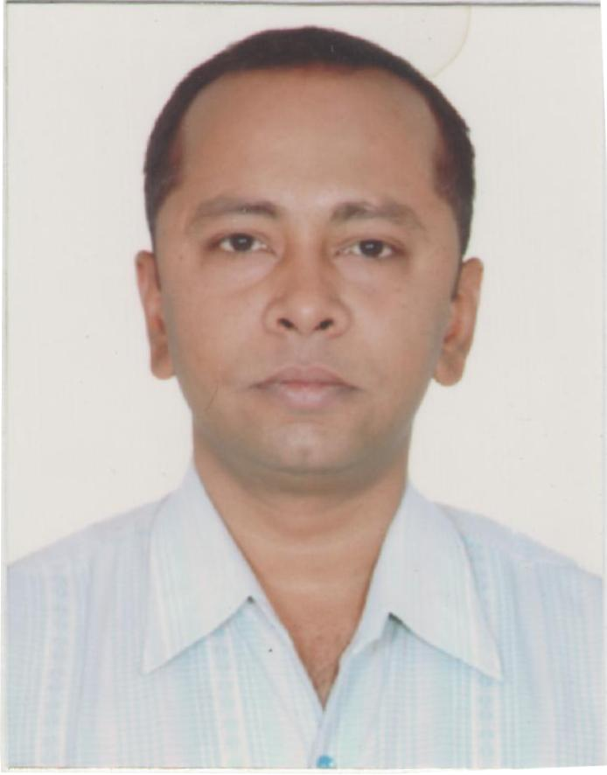
1. Permanent Address
89 Manohar Enclave,
Behind Gokul Appt.
City Center
Gwalior - 474011
Contact No. : - +91 (0) 9827586243

2. Career Objective
Seeking a position where I can explore my skills and abilities in the environment that offers Professional growth while being resourceful, innovative and flexible.

3. Academic Qualification

Class | Result
Dual MBA  (Hospital Management / Marketing) | I Division
B. Com. | II Division
12th | II Division
10th | III Division

4. Work Summary

Organization : Presently working with Kalyan Memorial & K.D.J. Hospital.
Date of Joining : Feb. 2008 to Till Date.
Title : Administrative Officer.
Location : Gwalior

RESPONSIBILITIES:
- TPA Manager.
- Incharge Admin Department.
- Incharge Billing Department.

Organization : Presently working with MEDX health convenience
pvt. Ltd.
Date of Joining : Feb. 2015 to Till Date.
Title : Marketing
Location : Gwalior

RESPONSIBILITIES:
- Responsibility for Marketing, Communication and Sales activities for the Company.
- Supervise staff members, ensure continuous training, support and guidance.

Organization : Working with Kalyan IVF Center
Date of Joining : Feb. 2010 to Till Date.
Title : Marketing
Location : Gwalior

RESPONSIBILITIES:
- Responsibility for Marketing.
- Ability to understand and translate client briefings into appropriate briefings.

Organization : SIFY LTD.
Title : Customer Care.
Date of Joining : Aug. 2003 to Jan 2008.
Location : Gwalior

Organization : Worked with Sify Ltd.
RESPONSIBILITIES:
- Handling the Customers.
- Handling the Event Management.

Organization : Hotel Ambassador Sky Chef.
Title : Flight Executive.
Date of Joining : Jan. 2003 to Feb 2003.
Location : Delhi

Organization : Worked with Hotel Ambassador Sky Chef, Delhi.
RESPONSIBILITIES:
- Handling the Operation Department.

Organization : CATALYST TECHNOLOGY.
Title : Lab Assistant.
Date of Joining : Jan. 2002 to Dec. 2002.
Location : Gwalior

Organization : Worked with Catalyst Technology.
RESPONSIBILITIES:
- Handling the Customers.

5. Extra Curriculum Activities
- Member of College Badminton Team.
- Participated in University Badminton Competition.
- Participated in University Table Tennis Competition.
- Participated in School Badminton Competition.
- Participated in School Table Tennis Competition.

6. Computer Literacy :-
- Done 3 months Diploma in Computer Office Assistant Course from Atal Bihari Vajpayee Institute, Gwalior.
- Done 1 Year Computer Diploma from NEC ITI, Gwalior.

7. Technical Skills
- Done Cabin Crew, Food & Beverages, Customer Service Training from Delhi Aviation Academy.

8. SPECIAL SKILLS
• Excellent customer service skills
• Basic computer and math skills
• Attention to detail
• Strong interpersonal and communication skills
• Knowledge of customer rights, aseptic and sterile techniques
9. Hobbies
Playing Badminton, Travelling.

10. Linguistic Languages

- English :- Reading, Writing, Speaking (With Perfection).
- Hindi :- Reading, Writing, Speaking (With Perfection).

11. Personal Profile

Name :- Yogesh Shukla
Date Of Birth :- 12th Dec. 1980
Sex :- Male
Marital Status :- Married
Father's Name :- SQN LRD K. P. Shukla (Retd. from Air Force)

12. Career Summary

- Overall Exposure of Customer Service.
- Good Academic and Technical Skills.

Place : Gwalior
YOGESH SHUKLA

