DEEPU LAL BALAI
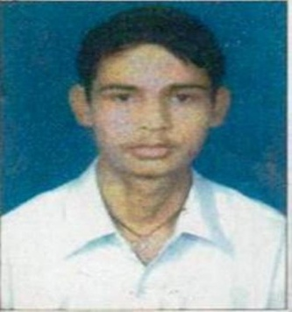 Village- KACHNAR POST – sawarda
Teh.- mojambad dudu , jaipur raj.
Email id-:deepulalverma111@gmail.com
Mob: 8504051951
WORKING EXPERIENCE

- Reception & store accounts in “hi- tech mobile comp.pvt.”. 1 year( 18 march 2013 to 10 march 2014
- Reception, &CASHIER , DATA ENTRY OPERATOR or OT ASSIST AND ,accounts & store incharge & cash less, Optical sales executive in working in ASG HOSPITAL PVT LTD. 2 YEAR ( 28 march to 29 feb 2016 ) asg eye hospital in optical working in 1 years
- Operaction Executive post on worked Eye-q vision pvt ltd 1 march 2016 to up to

WORKING ROLES
- Leading the all management of front office (IPD & OPD) and billing department
- Handles the all payments of parties.
- Audit for quality in work.
- Trainer in front office
- Provide data to hospital consultants to fully inform their decision making.
- Settlement of claims in TPA cell and taking receivables from health insurance companies.
TECHNICAL SKILLS
- Knowledgeable in computer application Such as MS excel, MS word, MS power point, tally Erp 9, Hospital information system software (Health Care Attune).

OTHER SKILLS
- Skillful in coordinating with and directing many personnel.
- Have excellent interactive and public relation skills.
- Good Presentations skills.
- KNOWLEDGE -
- OT ASSIST – CATARACT, VR , SQUINT ,and good knowledge of all minior process
- optical glass about knowledge and all multipurpose work knowledge
Computer skills
Basic knowledge computer, ms word, excel English typing and cum hindi typing
Tally and accounting billing

EDUCATIONAL QUALIFICATIONS
b.eb from rajasthan university in 2014
- Graduation in commerce university rajasthan 2013
- Senior Secondary, raj. Board ajmer 2010
- Secondary, raj. Board ajmer 2008

PERSONAL DETAILS
- Father’s Name : Late mr. moti lal
- DOB : 017.07.1993
- Nationality : Indian
- Marital Status : Single
- Languages Known : Hindi

