CURRICULUM – VITAE
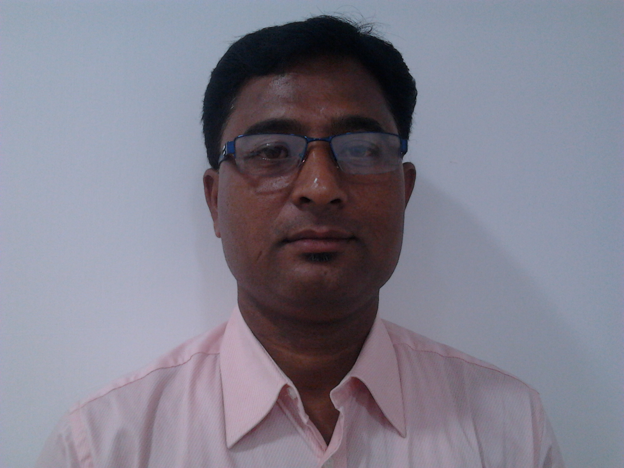

SANKAR GHOSH
CONATC NO: 9432473877
E-MAIL ID: sankar_exe@rediffmail.com

OBJECTIVE
Being a committed team player, want to be a part of a renowned organization, to contribute towards the growth of the Organization, based on my innovativeness and to further my personal capabilities by learning from the new exposure within the structured framework of the organization.

PERSONAL DETAILS

FATHER’S NAME : Lt Dhirendra Nath Ghosh

DATE OF BIRTH : 19-7-1967

NATIONALITY : Indian

RELIGION : Hinduism

MARITAL STATUS : Married

EMAIL-ID : sankar_exe@rediffmail.com

ADDRESS : Narayanpur,Kumarbagan,PO-Bandel,
DT-Hooghly Pin-712123
&
Shapoorji Pallonji Complex. Rajarhat .
Flat no – B/183/0404 .. Fourth Floor .
Kolkata – 700156 .

EDUCATIONAL QUALIFICATION

Name of  examination | Year of  passing | Board/  University | Name of the School/College
Madhyamik | 1983 | West Bengal Board of Secondary Education | Bandel Vidyamandir
Higher secondary  (commerce) | 1986 | West Bengal Board of Higher Secondary education | Rishi Bankim Ch College
B.com | 1988 | Calcutta University | Nabagram Hiralal Paul College

TECHNICAL SKILLS : Windows, Ms-Office, Internet

Working Experience

- ACCOUNTS TRAINEE: R.K. AGARWAL & ASSOCIATES. CHARTERED FIRM.3A CHOWRINGHEE PLACE.2ND LOOR.KOL-13,FROM 1ST AUG 1990 TO 31ST MAY 1995.

- ACCOUNTS ASSISTANT: HINDUSTAN LEVER LTD. C & FA, ALIPUR GARHI.OLD DELHI.FROM 7TH JUNE 1995 TO 20TH APRIL 2000.

- MANAGER DESK: VENUS DIAGNOSTIC CENTRE.58/4 RAJA DINENDRA STREET.KOL-16,FROM 26TH APRIL 2000 TO 31ST MAY 2009.

- PRESENLY WORKING AS A ASTT. MANAGER :DESUN HOSPITAL & HEART INSTITUTE.EM BYPASS KASBA GOLPARK KOL-107.FROM 1ST JULY 2009 TO TILL DATE . MAINTAINING MARKETING ACCOUNTS , PURCHASE DEPT (STENT, PACEMAKER ,VALVE ,CATH LAB ACCESS, PHARMACY). PATIENT COUNCILLING, CREATIVE DEPT ,CAMP ARRANGEMENT ETC .

- PRESENT SALARY : RS. 3,84,000 / -PA

- EXPECTED SALARY : Negotiable

Place : Kolkata S A N K A R G H O S H
Date : (Signature of Candidate)

