Application For the Post of Operation Theater Co-ordinator

COVER LETTER

Respected Sir/Madam,

My Name is Shyam Prasad. I have completed my Bachelor Degree in Computer Application from M.D.U. Rohtak. I have knowledge of MS-Office as well as of Internet and also possess a good typing speed. I have also done a Diploma in CCC (DOEACC) from Lal Bahadur Shashtri Training Institute Lucknow. I also possess more than Three years of working experience in Asian Hospital Faridabad as a O.T. Coordinator. Presently I have working in Nayati Multi Super Speciality Hospital Mathura as a O.T. Coordinator from 9th November 2015 to till.

I believe that my qualification will be consistence with those desired by you. I have enclosed my resume for your review. I would like to have an opportunity to meet & share more about my qualification & the ways in which I can contribute to my team and the organization.

Thanking You!

Yours Truly,

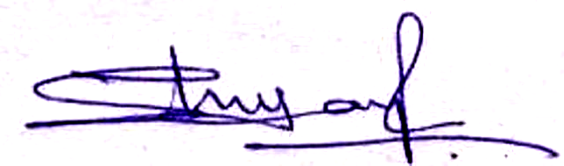

Shyam Prasad
(+91-8860473339)

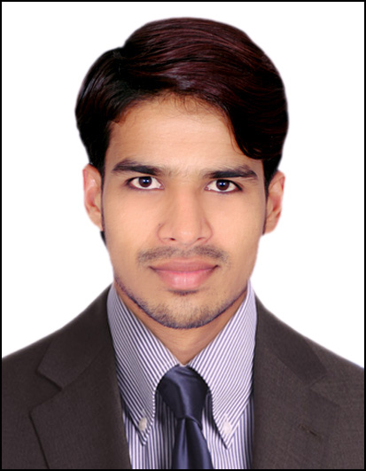
SHYAM PRASAD

Address: 685, Santnagar old FBD.
Haryana: 121002
Phone: +918860473339, 8532874620
E-mail: shyamyadav12790@gmail.com,

Career Objective
“To work in a respectable organization to the best of my ability, utilizing all the experience and knowledge acquired by me, and work for the development of the organization”.

Academic Qualifications
Examination/Degree | Institution | Performance | Year of Pass-out
Higher Education  (10th) (U.P. Board) | R.M.I College Pure  Talewand Raibarely  (UP) | Aggregate : 54.0% | 2007
Higher Secondary  Education (12th)  (U.P. board) | Shree Darbari Lal Inter  College Kalva Mau.  (Faizabad) (U.P) | Aggregate : 59.8% | 2009

Professional Qualification
Examination/Degree | Institution | Performance | Year of Pass-out
B.C.A  (M.D.U. Rohtak) | Pt. J.L.N Govt. College  Sector-16,  Faridabad(H.R) | Aggregate: 63.30% | 2012
Diploma  CCC (DOEACC) | Lal Bahadur Shashtri Training Institute Lucknow | Aggregate: 70.30% | 2013

Working Experience & Training Project
- Presently working in M/s. Nayati Multi Super Speciality Hospital Mathura, as an Operation Theatre Coordinator from 9th November 2015 to till.
- Worked in M/s. Asian Institute of Medical Sciences Faridabad, as an Operation Theatre Coordinator & Billing from 1st October 2012 to 15th October 2015.
- One year worked as a Tally calling & Computer Entry Operator in JIVA AYURVEDA Shahni mode Faridabad.
- One year experience in National Modern ITI Old Faridabad as a Basic Computer Assistant.
- Six months worked in Shere Punjab Industries Old Faridabad as a Billing of Tools.

My Roles & Responsibilities:-
- Worked as OT Coordinator and coordinate the cases as per the availability of OT and doctors timing.
- Check that everything to be done when patient comes for OT and schedule according to that.
- Generate bills of the patient who comes in OT as per their procedure charges (Surgery Codes).
- Confirm the proper functioning of the departments.
- Maintain of all surgeries in monthly and make final data in ends of the months.
Technical Skills

Programming Skills | Visual Basic, C, C++, Core java.
Web Developer software | HTML.
Software & Tools | MS-Word, MS-PowerPoint, MS-Excel (2003, 2007).  E-mailing and Making project on net.

Strength

- Self-belief
- Hard worker
- Honest
- Responsible

Hobbies & Interests

- Net surfing
- Do Program on computer.
- Listening to music.
Personal Details

- Father’s Name : Mr. Ram Narayan Yadav
- Marital Status : Married
- Permanent Address : 685,Santnagar old Faridabad, 121002
- Date of birth : 12th Jul1990
- Gender : Male
- Languages Known : English, Hindi
- Nationality : Indian

References:-

- Dr. Naintara Batra 2) Dr. Divesh Arora
Head & Director (Anesthesia) Sr. Consultant & HOD – Anesthesia & OT
M.B.B.S (BHU) M.B.B.S (AFMC)
M.D. (Anesthesia, BHU) M.D. (Anesthesia)
Mob: - +91- 9650099103 (Gold Medalist, NABH Assessor)
Mob: - +91- 9650099113

3) Dr. Yuvraj Kumar 4) Dr. Prabal Roy
Sr. Consultant & HOD – Orthopedics Director (General Surgery)
MBBS, M.S. (Ortho), MRCS (I), FIMS (U.K) MBBS, MS, FICS, FAIS, FIAGES
Mob:- +91 – 9650099235 Mob: - +91 - 9650099199

Declaration:-

I hereby declare that the above mentioned information is correct up to my knowledge and I bear responsibility for the correctness of the above mentioned particulars.

Date: - ………. /……… /2016
Place:-Faridabad (H.R.)

Shyam Prasad
SHYAM PRASAD

