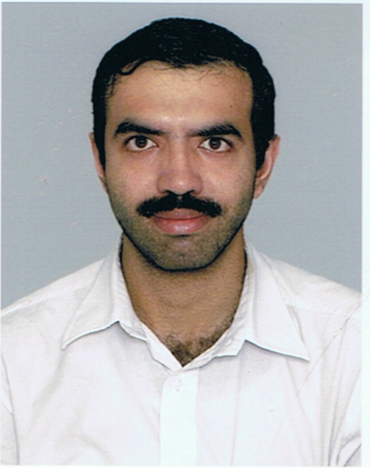

PRITHVI BHUSHAN PRABHAKAR
#52, Anand Apts, Apt D2, 3rd cross, Eshwarnagar
Banashankari II Stage,
Bangalore-560070
Contact: 9900452704, 9900170731
E-mail: prithvi_bhushan@yahoo.co.in
prithvi.bhushan12@gmail.com

CAREER OBJECTIVE

- To use my managerial & leadership skills and abilities to the maximum extent, where I get an opportunity to learn, exercise and build the same for a mutually beneficial relationship with the organization
- To map my potentials to the Industry standards & requirements and nurture my Leadership qualities which I have cultivated.
- To utilize my knowledge towards organizational excellence and to nurture my Professional Aspirations.
- To create a healthy and friendly atmosphere around me in the organization and show the world that people from all parts of the world can successfully co-exist and show the world the wonders each of those brains can do.

CAREER SUMMARY

- MBA/PGDBE with specialization in HRM
- Worked across diverse functions like support services and team management.
- Adept at providing service operations; understanding clients’ requirements and providing services accordingly; leading teams to ensure the accomplishment of service deliverables.
- An effective communicator with excellent relationship, management skills and strong analytical, problem solving and organizational abilities.

Key Strength Areas:
- Recruitment
- Training & Development
- Statutory Compliance

Current Employment:

Company : Sagar Hospitals
Location : Bangalore, Karnataka (India)
Position : HR Executive
Experience: 4th October, 2010 till date
Work Profile
- Interviewing the candidates
- Issuing offer letter and appointment letter and opening bank account
- Drafting letters, performing clerical duties and issuing bank kit
- Inducting the new joinees and monitoring the attendance
- Updating the training records, maintaining and updating employees' personal files
- Performing the duties of a “Data Entry Operator” in the system and updating
The job demands good communication and interpersonal skills with good co-ordination & planning.

Previous Employer details:

Employer 1:

Company : JCR Drillsol Private Limited
Location : Bangalore, Karnataka (India)
Position : HR Executive
Experience: 1st December, 2008 to 29th September, 2010
Work Profile
- Interviewing the candidates
- Issuing offer letter and appointment letter and opening the bank account
- Drafting letters, performing clerical duties and issuing bank kit
- Performing the duties of a “Data Entry Operator” in the system and updating

Seminars & Trainings Attended

- “Cutting Edge Camp” at Delhi and Noida
- Training on Integrity, Problem solving

ACADEMIC CREDENTIALS

Post Graduate Diploma in Business Economics (HRM) 2008 - 2010
Wigan & Leigh College India

Bachelors in business management (BBM) 2002 - 2005
Dayananda Sagar College - Bangalore
Vijaya Composite PU College (PUC) 2001
Pre-University Board
Secondary School Certificate (SSLC) 1998
Carmel School, Padmanabhanagar – Bangalore

IT Skills

- Well versed with Windows 98 / XP, MS Office, C, C++ and the Internet.

PERSONAL DETAILS

Date of Birth : 13/11/1982
Marital Status : Married
Extra Curricular Activities : Playing Sports – Indoor Badminton, Swimming, Cricket, Carrom
Languages Known : English, Kannada, Hindi
Nationality : Indian

REFERENCES

- Mrs. Gayathri Reddy, JCR Drillsol (P) Ltd, Executive Director, gayathri@jcrdrillsol.com
- Dr. Vinayak K Naik, Ex – GM HR
I hereby declare that all the information stated above is true and complete to the best of my knowledge and belief and nothing has been concealed / distorted.

Place: Bangalore

Date:

