CURRICULUM VITAE

Prabhaker yadav 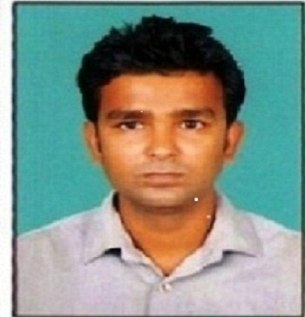
H.NO.737, sector-1
R.K.Puram
New Delhi – 110022
Mobile No.- 9716037874
E-mail – Rokery61@gmail.com
OBJECTIVE
To work in challenging atmosphere which provides ample of opportunity for learning and growth in career with best of my efforts to fulfill the goals of the organization. Further sharpening of my knowledge gaining capability and also assists the Company at management.
Educational Qualification:
- 10th passed from C.B.S.E BOARD.
- 12th passed from C.B.S.E BOARD.
- Graduation from Delhi University (Dayal Singh College , B.A. Programme)
- Pursuing M.com from IGNOU University 1st year
Computer Knowledge

Manual Accounting,MS Word, MS Excel, Power Point,Photo shop,Fundamentals and Networking,Operating System, Internet

Work Experience :
Designation –Process Associate
Duties and Responsibilities:-
Processing E- Checks
Reconcillation of customers accounts vendor accounts
I have worked as a process associate in genpact for more than two years (2.4 years) In banking process .(2008 to 2010).
Currently Placed
MUTHOOT FINANCE LTD (December 14 , 2015 – at Present)

Designation –Senior Accounts Assistant
Duties and Responsibilities:-

In-charge for internal Preparation of Trail Balance sheets and Final Accounts for Subsidiary Companies audit
Maintenance of Books of Accounts manually Preparation of Bank reconciliation statements
Reconciliation of Customers accounts Vendor Accounts
Daily Transactions of Banking (Payments, Receipts & Transfers)
Preparing Aging Reports for AR & AP
Preparing Quarterly and Yearly Financial Reports (Trading Accounts, P&L)
Accounts, Balance Sheet & Asset Accounting
Deal in Forrex
Appraising the gold loans
Money transfer transactions
Cash maintenance traction(cashier)
Operation of white label ATM

Strengths:

- Positive attitude, self-confidence & cool tempered.

Personal Details

Name : Prabhakar yadav
Father’s Name : Mr.R.S.yadav
Mother’s Name : Rama yadav
Date of Birth : 15th march. 1986
Marital Status : Single
Languages known : English, Hindi

Date:
Place: (PRABHAKAR YADAV)

