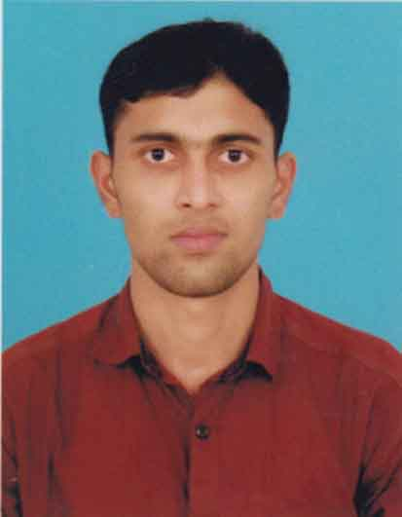
CURRICULUM VITAE

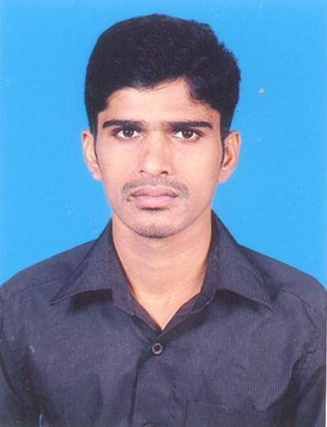

PERSONAL DETAILS

Name : JYOTHIS JOSEPH
Sex : Male
Date of Birth : 22-05-1989
Father’s Name : Joseph.M.M
Religion : Christian
Nationality : Indian
Marital Status : Single
Mail Id : jyothisjoseph2012@gmail.com

Permanent Address : Mundakkal (H)
Palakkayam (P.O)
Palakkad Dt,
Kerala – India -678591

Mob no : +91 9605707138

Languages Known : English, Malayalam & Tamil
Passport Number : J 5703629
Date of exp. : 10/01/2021
Place of issue : PALAKKAD

- Comprehensive problem solving abilities.
PERSONAL QUALITIES
- Ability to deal with people friendly and inquisitiveness to learn new things.
- Team facilitator and organizer, fast grasping and highly responsible.
- Quick adjustment to the new situation and work.
- Good personality, character ethics and hard worker.
Objectives

- To work in a professional environment so as to enhance my skills and work to my full potential.
- Leads to a corporation among team members in conjunction for the objective of the organization.
- To attain a good position in among the team members and the organization with hard work and team spirit.

EDUCATIONAL QUALIFICATION

Course | Board | Name of the Institution | Marks in percentage | Year of Passed
G.N.M | KARNATAKA STATE DIPLOMA IN NURSING EXAMINATION BOARD | KREDA SCHOOL OF NURSING | 61 | 2010
PLUS TWO | KERALA HIGHER SECONDARY EXAMINATION | KALLADI HIGHER SECONDARY SCHOOL KUMARAMPUTHUR | 58 | 2006
S.S.L.C | Kerala State Board | D.B.H.S THACHAMPARA | 65 | 2004

EXPERIENCE: 6 ½ YEARS

CHARGE NURSE : OPERATING ROOM
1st AUGUST 2015 to present
ATHANI HOSPITAL
PALAKKAD
KERALA , INDIA

STAFF NURSE : OPERATING ROOM
1st JUNE 2012 to 31st JULY 2015
ATHANI HOSPITAL
PALAKKAD
KERALA, INDIA

STAFF NURSE : OPERATING ROOM
15 JULY 2010 to 29 MAY 2012
ESAF HOSPITAL& RESEARCH CENTRE
THACHAMPARA, PALAKKAD
KERALA, INDIA

PROFESSIONAL BACKGROUND

Complete Address of Licensing Body : THE KARNATAKA STATE NURSING COUNCIL
REGISTER No: 128935
Date of Registration: 17 MARCH 2010

SURGERY ASSISTED AS SCRUBBED AND CIRCULATED

ORTHOPAEDIC SURGERY
Total Knee Replacement , Total Hip Replacement , Anterior & Posterior Cruciate ,Ligament Reconstruction, D H S, D C S, I L N Tibia, Femur & Humerus, O R I F with Plate & Screw of Humerus, Radius, Ulna, Femur, Tibia, Fibula, Calcanium, Clavicle, & Pelvis. Arthroscopy & Menisectomy, K- wire, Amputation.

SPINE SURGERY Laminectomy, Discectomy, Spine fixation.

LAPAROSCOPIC SURGERY
Lap Cholecystectomy, Lap Appendectomy, Lap Hysterectomy, Lap Sterilization.

GENERAL SURGERY
Thyroidectomy, Mastectomy, Laparotomy, Cholecystectomy,
Appendicectomy , Hernioplasty , Splenectomy, Prostatectomy , T U R P
Haemarroidectomy , Hydrocele Repair , Orchidectomy,varicose vein ligation.

E N T SURGERY
Adeniodectomy, Tonsillectomy, Mastoidectomy , Tympanoplasty , Myringotomy ,
Stepedectomy, F E S S, Polypectomy, Septoplasty, M.L.S.

OBSTETRICS AND GYNECOLOGY SURGERY
L S C S
Abominal and Vaginal Hysterectomy
Myomectomy
Bilateral Tubal Ligation
Cervical cerclage
Dilataion and Curettage
Excision of Barthol

DUTIES AND RESPONSIBILITIES

SCRUB NURSE
- Scrub few minutes ahead than the surgeon and prepares instruments and other equipments aseptically
- Serves or assists the surgeon in putting gown and gloves
- Assist the surgeon in draping the patient
- Counts with the circulating nurse all instruments , sponge, gauze, patties, sharps before and after the operation
- Maintain an accurate count of instruments, sponge, gauze and sharps
- Handles instruments and other required items to the surgeon properly
- In extreme cases ,act as first assistant to the surgeon, interacting and exposing the operative site for the surgeon' view
- Alerts the circulating nurse with regards in adding other instruments, materials,and other needs during surgery
- Anticipate the needs of the surgeon throughout the operation
- Consciously alert on the entire operation, taking note of the cutting time,time specimen is secured , closing time, instrument and sponge count, security of needles and thread.
- Implementing the sterility of the entire operation
- Wound dressing
- Ensure that patient and gown is clean
- Returning the instruments for washing and sterilization
- Completing the documentation

CIRCULATING NURSE

. Act as manage of the operating room
- Check all equipments if they are all working properly prior to surgery
- Ensure the availability and sterility of instruments for surgery
- identify the patient correctly
- Assist in positioning of patient for anesthesia and surgery
- Safeguard the patient once anesthesia is induced
- Perform skin preparation aseptically
- Assist the Anesthesiologist in monitoring vital function
- Label and document properly all the specimen
- Act as bridge in co-ordinating with other departments
- Make accurate documentation of the entire procedure
- Promotes smooth and safe function of the operating room
- Responsible in keeping or preserving the individuality of the patient
- Close observation of the patient
- Endorse patient properly to incoming charge nurse at the of the shift

HOSPITAL EQUIPMENTS / MACHINES HANDLED

- Monopolar and Bipolar cautery machine (ERBE ,Schiller , Conmed, Vallelab)
- Suction machine (Aerosol Medical)
- Cardiac Monitor (Spacelab ,Dragger ,Siemens)
- Pulse Oxymeter (Drager ,Siemen,Schiller)
- Laparoscopic monitor , camera, light source , co2 gas ( Arthrex ,
Storz )
. Tourniquet machine (Zimmer)
- Syringe pump
- Infusion pump
- DVT
- Compact Air drive ( Synthes)
- Mini Compressed drill
- Stryker Drill
- Arthroscopic Shaver system
- ECG machine
- Defibrillator
- C-ARM machine ( Siemens , Philips)
- CISA and Stryker instrument sterilizer
- Microscope
- Laryngoscope
- Bronchoscope
- Fexible Endoscope
- Laparoscope
- Anasthesia Workstation (Dragger)

PROFESSIONAL DEVELOPMENT

Infection Control Management Certificate

REFERENCE

Mrs. MERCY AUGUTHY
Nursing Director
Athani hospital
Palakkad
kerala
New Delhi
Ph: 09745633490

declaration
I here declare that the above said information is true in the best of my knowledge and belief.

Yours Respectfully
Place: Palakkad
Date : 10/10/2016 JYOTHIS JOSEPH

