CURRICULUM VITAE

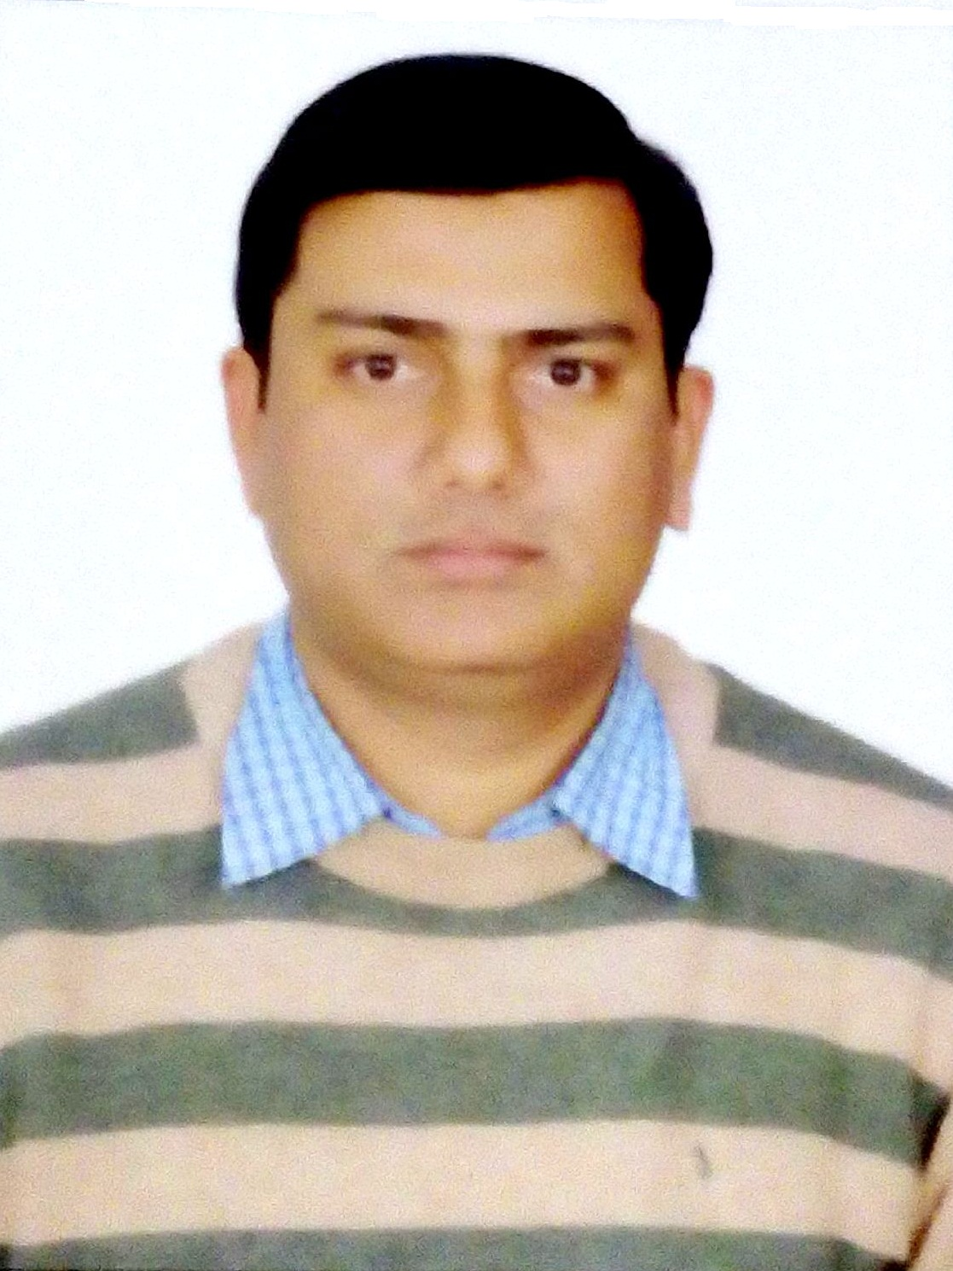
MOHD.BILAL
D-67, First Floor, Shaheen Bagh, Okhla, Jamia Nagar, New Delhi-25
# 9891708055, 8750337835 Email: bilallookman@gmail.com

OBJECTIVE

Seeking a Human Resources Management position where my professional experience and education will allow me to make an immediate contribution as an integral part of a progressive company. Wishing to apply my business experience and education to assist the company in the accomplishment of its goals.

PROFESSIONAL SYNOPSIS
- MBA (HR )Enthusiastic, results oriented HR professional with extensive 8 years of experience in Human Resource management and planning of directing all areas of Human Resources that includes but is not limited to: benefits, compensation, employment law, employee relations, on-boarding, payroll, performance management, policy & procedures, recruitment, administration, welfare, supervision & training.
AREAS OF EXPERTISE:

Recruitment

Employee Relations / Welfare

Payroll Management

Compensation & Benefit

Full & Final Settlement

Salary process

HR Policy Execution
CARRER HIGHLIGHTS
5. Currently I am working with Sanjeevan Hospital (Daryaganj) as a Manager-HR from Jan.2015 till date.
4. I have worked with Deusch Kyosei Engineering Private limited as a HR-Manager from August-2014 till Dec-2014. (Deusch Kyosei Engineering pvt.Ltd. a joint venture company with Kyosei Japan is one of the leading global manufacturers of high quality control cables for automobiles, construction, and agriculture machinery.

3. I have been worked with W-Lifestyle India Private Limited,(Westinghouse India Pvt.Ltd) as a HR Manager, from date 17th Nov-2013 to till 31th July-2014. (A consumers durable electrical products Manufacturing Company of home appliances & Kitchen appliances)

Job Responsibilities:

- Handling the entire recruitment and selection process.

Recruitment, on-boarding and planning human resource requirements in consultation with heads of different functional & operational areas and supervise the recruitment and on-boarding process.

Manage the interview & selection process.
- Responsible to manage and coordinate with consultancies on all the active job requirements.
- Handling Manpower Recruitments by sourcing profiles through advertisements, internal database, references, networking, organizing interviews, selecting and hiring candidates.
- Handling salary negotiation and compensation in line with industry standards.
- Carrying out joining and Induction activities of new candidates.
- Handling attendance, payroll, OD, leave records and overtime records of the employees.
- Handling Employee's personnel record documentation and maintenance, Employee details & Employee family background.
- Taking care of employee grievances
- Undertaking HR initiatives and organizing events
- Handling all Administrative activities like maintenance of Office equipments, housekeeping and maintenance of Office & record keeping of Office stationary including various formats.
- Team handling & maintaining employee’s personal files and database and all the general HR administration, Attendance and leave management process.
- Preparing monthly salary of all employees as per the schedule, cross checking salary file output based on received input file and sending it to accounts team for disbursement.

Updating the Attendance, leave details, Appraisals details, Increment details and Incentive details on payroll software.

Arranging & conducting Interviews/Initial screening the candidates/ coordinating in recruitment processes & training programs.

Prepare and submit all relevant HR letters/ documents/ certificates as per the requirement of employees in consultation with the management

Procuring all the leave applications/ on duty forms for salary process and records.

Maintain the Payroll Management and all statutory compliances records i.e. ESI & PF etc.

Conduct exit interviews for employees and record them accordingly.

Conduct employee orientation and facilitate newcomers joining formalities Maintain and regularly update (personal database) of each employee.

Maintaining Recruitment Data &. Create & update Job Description

2. Lookman Electroplast Industries Ltd. HR-Assistant Manager (North India)
April 1st-2010 to till Oct.-2013 (Deal in CCTV Security systems ‘electronics products)

Job Responsibilities:

- Involved in full recruiting life cycle & end to end recruitment.
- Management and monitoring of all recruitment activities to ensure recruitment deadlines are met as per company policy
- Handling the Selection procedure like screening, scheduling and conducting Interview.
- Established selection procedures, including interviewing, testing and reference, and background checking.
- Day to day Attendance checking & Maintaining Leave Cards of On roll Employees.
- Checking & Maintaining of Overtime & late coming reports, Absenteeism Reports of On-Roll Employees etc.
- Responsible to manage and coordinate with consultancies on all the active job requirements, if necessary.
- Custodian of all HR Policies and Processes
- Responsible for grievance management process and maintain disciplinary standards of the organization.
- Responsible for all the exit formalities including Full and final settlement.
- Effective implementation of Reward and Recognition to appreciate high performers.
- Ensuring Event management on specific occasions thus ensuring Employee Engagement.
- Developed promotional campaigns for attracting best talents from industry, which includes activities such as Campus Hiring, LinkedIn postings, Job Sites (Naukri & Monster), Newspaper advertisements, Employee Referral Programs, Mass Walk-ins, Outstation Recruitment drives, Tie-ups with Training Institutes.

1. Dr. Shikha’s Nutri- Health Systems Pvt. Ltd- Sr.Executive-HR May’07 to Feb’2010 (Healthcare Company)

- Responsibilities:
- Head hunting through portal, short list the candidate’s resumes for interview.
- Calling the candidates for interview.
- Conduct the Walking Interview.
- Assist in recruitment & selection process.
- Complete the documentation process and verification.
- Arranging the induction program for the new joiners & documentation.
- Handling employees joining & Exit formalities.
- Maintaining the attendance of the employees.
- Calculating & processing the salaries of the employees.
- Taking feedback from previous employers.
- Implementing the talent acquisition strategy by sourcing resumes through a combination of Job Portals, Website, and Referrals & Consultants as per the needs of the organization.
- Screening of profiles, interviewing, selecting, ensured the tracking and organizing of all the applicant data.
- To create personal files and maintain them throughout the lifecycle of the employee.
- Facilitating Exit interviews and providing feedback to the management.
- Regulating and enforcing HR discipline like attendance, working hours etc. and monitor a sound work culture within the organization
- Preparing the Offer letters & Appointment letters for the selected candidates.
- Assisting the HR manager with other HR activities.
- .

QUALIFICATION
- MBA from Jamia Millia Islamia University
- Graduation in B.A (Hon.) from Jamia Millia Islamia University.
- Intermediate from Jamia Senior secondary School Delhi 1998
- High School from UP. Board 1995

PERSONAL INFORMATION

- Father’s Name: Mr. Mohd. Intakhab
- Sex: Male
- Marital Status: Married
- Nationality: Indian
- Date of Birth: 01-Jan-1980
- Language Known: Hindi, English & Urdu

STRENGTHS:
- Leading by example
- Professional attitude with mature mind
- Willingness to take challenges outside the comfort zone.

- I hereby declare that the information furnished above is true & best of my knowledge.

Date:
Place: (MOHD.BILAL)

