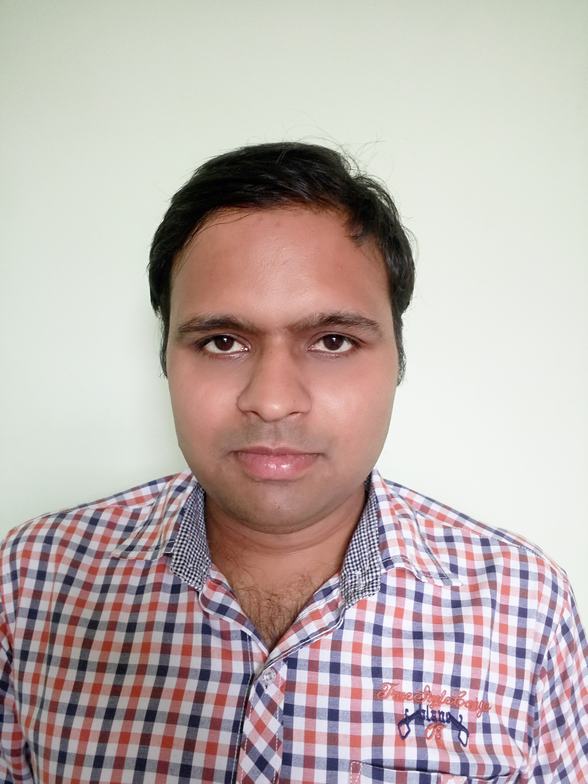
CURRICULUM VITAE

Dr. VIVEK BHARDWAJ
Contact No:- 9350517007
Plot no 3 naresh park najafgarh road nangloi email-id vivekbhardwaj32@yahoo.in

EDUCATIONAL QUALIFICATION:

- B.A.M.S from Gaur Brahman – Ayurvedic College Rohtak.passed on jan 2006

- Six months Panchkarma Diploma from Maharishi Ayurvedic Hospital Shalimar Bagh, Delhi.

CLINICAL EXPERIENCE

- General Hospital Gurgaon

- Misson Hospital Bahadurgarh

- Bimal Hospital Nangloi.

- Sonia Hospital Nangloi

WORK EXPERIENCE

- Working as a Ayurvedic Consultant & General Physician at Nangloi

- Working as a Wellness Consultant in Green Shield Health Care Pvt. Ltd
- Working as general physician for last 5yrs at pvt clinic

PERSONAL DETAILS:

Father’s Name : Sh. Maha Singh

Date of Birth : 25th Oct 1981

Martial Status : Married

Nationality : Indian

Language Known : Hindi ,English & Sanskrit

PLACE : …22-12-2006………….

DATE : …delhi…………. (Dr. VIVEK BHARDWAJ)

