Resume
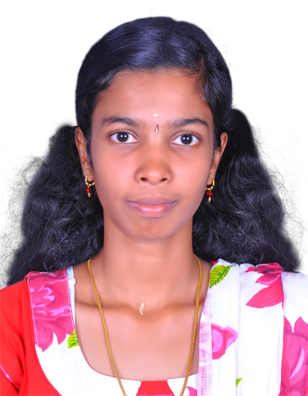
UGIN GLADIS. D.
65A/302, East Sargunaveethi,
Ramavarmapuram,
Nagercoil 629 001.
Email id : ugingladis@gmail.com Mob:8220381373

RESUME

NAME : D.Ugin Gladis
PERMANENT ADDRESS : D/O A.Dharmaraj,
65A/392,East Sargunaveethi,
Ramavarmapuram, Nagercoil-629001,
Kanyakumari (DT).
Phone: +91-8220381373
E-mail: ugingladis@gmail.com

DATE OF BIRTH : 24.08.1994
AGE : 23 yrs
SEX : Female
FATHER’S NAME : Mr.A.Dharmaraj
MOTHER’S NAME : MRS.Thanga Lissy
MOTHER TONGUE : tamil
LANGUAGES : Read – English, Tamil,Hindi
Write – English, Tamil,Hindi
Speak – English, Tamil, Malayalam and Hindi

PASPORT NUMBER : N3760276 EXPIRARY DATE :11/10/2025
REGISTRATION
COUNCIL : THE TAMILNADU STATE NURSING COUNCIL.

REGISTRATION DATE : THE TAMILNADU NURSES & MIDWIVES COUNCIL & 26/02/2016

RN / RM No : 163525

Objectives:

To be serious in multiple curves this will help me in utilizing my technical and Interpersonal skills to achieve a position of responsibility and respect in the Corporate world.

Educational Qualification :

Examination | Institutions | Board / University | Year of Passing | %
S.S.L.C | Amala Convent Higher Secondary School,Thuckalay, Kanniyakumari District. | State Board | 2009 | 71.9
H.S.L.C | HolyAngels Matriculation Higher Secondary School,Chenthari, Kanniyakumari District. | State board | 2011 | 67.4
B.Sc Nursing | Sakthi College Of Nursing. Oddanchatram, Dindugal District. | MGR University | 2011-2015 | 78

EXPERIENCE:

1.ANNAI ARUL HOSPITAL
NICU Staff Nurse – October 2015 to till now
Job Responsibilities:
Taking Care of Ventilator, Premature and Sick Babies.
Maintaining Sterility to avoid Infection.
Provide focused care to babies born prematurely in NICU care setting.
Provide intensive nursing care to seriously ill babies.
Resolve complex issues in NICU nursing care issues.
Assist obstetricians or other doctors providing treatment to newborn babies.
Basic Care such as Changing Diapers and Bedding.
Administer Medication, IV Fluids and Oxygen Therapy.
Feeding Patients and Inserting Feeding Tubes for Babies too ill.
Monitoring Babies Vital signs, Temperature, Pulse and Heart Rate.
Ensuring Infants Breathing and Proper Maturity.
Providing Direct Patient care for New born Babies.
Analyzing and Evaluating the Effectiveness of care to Babies and Mother.
Interpreting Clinical results and Initiating Investigations.
Providing Clinical Support to Staff and Students.
Preparing Documents and Administrative records.
Making sure surgical equipment is clean and safe to use.
Regularly undertaking managing of unit under the supervision of senior staff.
Preparing Nurse Care plans.
Teaching parents how to maintain newborn health at home.
Creating a welcoming, caring and safe environment for neonates and their parents.
Able to work responsibly under own initiative.
Able to assess a neonate’s physical, psychological and social problems.
Reporting and investigating any untoward incidents.Performed Admission, Discharge and Transfer procedure and assisted with Patient’s activities and care.
Implemented physicians order for all assigned patients safely and properly administered medications and treatments.
Recorded Physical status of babies reports assessment changes to the concerned authority.

CAREER SUMMARY:
A patient oriented and caring professional with excellent patience and remarkable organizing skills.
Proven record of reliability and responsibility.
Possess special sensitivity to meeting different needs in varied situations.
Establish contacts with patients, family, staff and physicians.

PERSONALITY TRAITS:

Remain calm and professional throughout critical incidents.
Excellent in communication skills in written and verbal both.
Resourceful problem solver capable of implementing solutions to complex problems.
Ability to work in pressure situation.

SKILLS:

Broad knowledge of interventions,
Preadmission assessment and testing,
Use of testing program flow charts.
Problem solver
Prevent accurate assessments for medical and surgical interventions.
Emphasis on patient education and the nursing process.
Conducts and develops complete, comprehensive and detailed analysis, evaluations and corrective actions.
Highly self-directed.

TECHNICAL EXPERIENE:

Proficient in all apparatus and equipment of NICU Ward.
Ventilator
Syringe & Infusion pump
Monitors
Incubator
Warmer
Phototherapy
Proficient in basic usage of computer.

COMPUTER PROFICIENCY:

Microsoft office

REFERENCE:
REFERENCE
Dr.AnoopM.D,DNB,
Annai Arul Hospital,
Chennai.

DECLARATION:

I (D.Ugin Gladis) confirm that the information given above is true to the best of my knowledge.

SIGNATURE

D.Ugin Gladis

