COVER LETTER

SHRAVAN KUMAR
E-68 VIJAY VIHAR PHASE-1
SECTOR-5 ROHINI NEW DELHI—110085
,9910206519, 9871874923

APPLIED FOR ….

NEW DELHI

Dear Sir/Madam,
I am writing in response to your company, after screening, I am confident that my skills and my passion for Investigation of genuinely of claim case are a perfect match for this position.
I would bring to your company a broad range of skills, include
Processing of claims and settlement includes the following:
- Accepting intimations
- Approving cashless claims
- Disbursing the claims
- Query management to all insurance company
- Empanelment of Hospital
- Spot visit of hospital.
- Check genuinely of claim case.
- Investigate the ongoing treatment of the patient
- Discuss about cause of diagnosis.
- Investigate of fraud finding.
- Check all record regarding billing of Hospital & medical store.
- Mail Drafting of daily work activities.
- Data Management
- Prepare all Investigated report.

I would welcome the opportunity to further discuss this position with you. I have enclosed my resume for your review, and I look forward to hearing from you.
Sincerely,
SHRAVAN KUMAR

SHRAVAN KUMAR 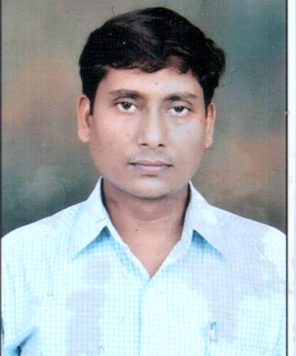
ershravan08@gmail.com
ContactNo, 9910206519 Positions: -

Professional Work Experience:-
- ERICSON TPA HEALTHCARE PVT LTD
- JUN-2014 –TILL DATE,
- INVESTIGATION OFFICER,
Role & Responsibility.
- Investigating genuinity of claim, document, ongoing treatment, treating history, about hospital facilities, bill genuinely.
- Area: Delhi ,NCR ( Faridabad, Noida,Ghaziabad,Gurgaon,Sonepat)
- M/S. CALYX BIOTECH
- Business Development Manager.
- Since Aug-2011 To May-2014
- Fortis Clinical Research limited, Sun Flag hospital, 16A Faridabad
(Jan-2010-31th jul-2011)
Phase-I swine flu Vaccination Trial and BA/BE Studies.
Job Title- CDA
Role and Responsibilities
- Assists the Clinical Data Manager (DM) in the identification of clean patients for QC. Creates QC listings from clinical database.
- Comprehensive Data Review (CDR)
- Database Testing
- Query generation, resolution and updating in database
- Data entry
- CRF Annotation
- Database design through `CDMS` Open Clinica, Oracle clinical 4.5.1and Epi Info

- G. Biosciences.U.S.A
Sector 59A Noida U.P
- 30 Days Practical Training program on GLP, Laboratory safety and Molecular and genomic studies.
- Central Institute of Medicinal and Aromatic Plants, Lucknow
- CIMAP Winter Training on Techniques and Tool of biotechnology and Bioinformatics (CWT-2007).
- Biotech Park in Biotechnology City, Lucknow
- One month (01st Aug-07-31st Aug-07) Project on Production of Bio diesel from
Jatropha curcus L.
- Mohan Goldwater Breweries Ltd
Daliganj, Lucknow
- One month Training on chemical analysis and Fermentation process.

COMPUTOR SKILL: Complete MS.OFFICE SUITE

EDUCATIONAL & PROFESSIONAL CREDENTIALS
Course | Specialization | Institute | Year of Passing
PGDCDM | Clinical Data Management | Clinical Research Education & Management Academy New Delhi | 2010
B.Tech | Biotechnology | Saroj Institute of Technology & Management. Lucknow | 2008

KEY SKILL SET:
Clinical Data Management through ‘CDMS’ Oracle Clinical 4.5.1 Open Clinica,Epi Info, Hand on practical of creating of creating of question, Question group, DCM, DCI, DCI BOOK, DATA ENTRY AND VALIDATION PROCEDURE,CRF ANNOTATION AND GCP GUIDELINE
HANDLING OF …
- Molecular bio- (Recombinant DNA Technology),
- Electrophoresis Techniques
- HPLC
- Chromatography
- Mass spectrometry
- Quantitative analysis
- Centrifugation process
PERSONAL PROFILE:

- B.Tech in Biotechnology with in-depth academic knowledge and practical project exposure.
- Outstanding researcher with analytical and logical bent of mind and comprehensive problem solving skills adorned with creativity and perseverance.
- Highly methodical and well organized in work habits with well-developed leadership and motivational skills.
- Excellent ability to summarize research findings, analyze/evaluate data & results and perceive patterns/structures.
- Strong problem solving & analytical skills, flexibility, resourcefulness & proven ability to work as part of a diverse team.
- Successfully qualified National Institute of Communicable Disease (NICD) Exam August 2008 New Delhi, for Master in Public Health (MPH).

Date:
Place: - Signature

