SHANTI SHARMA
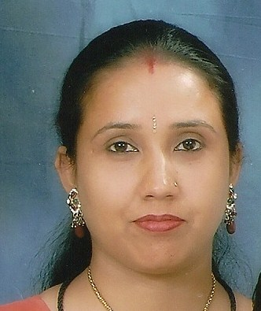
608, Krishana Gali No. 10,
Aadarsh Mohalla, Maujpur
Delhi-110053
Phone No: 9717821532
E mail: shantisharma58@yahoo.com; shantimisthi.sharma@gmail.com
VISION:
To help achieve excellence Acceptance of any challenge with confidence, enjoy the life, doing Social Service with Devotions without thinking time hours.

STRENGTH
Good interpersonal and communication skill. Balanced temperament, Adaptable to changes and circumstances. Acceptance of any challenge for doing work in any environment & make Standardization for any Office
PRESENT STATUS:
Working as Administrative Sr. Assistant in Indraprastha Apollo Hospitals, Sarita Vihar, New Delhi from August 2007 to till date
RESPONSIBILITIES:
TWO main sub Departments of the DNB Section i.e. Medical & Academic Advisor office. At present 27 specialties with an intake of approx. 130 DNB trainees. The workload of this programme has increased tremendously as under
DNB (DIPLOMATE OF NATIONAL BOARD)
- Preparation of application for accreditation/reaccreditation (Fresh & Renewal) & Inspection report.
- In case of any major deficiency reaccreditation application is send back to the hospital for necessary rectification and submission of compliance report.
- Conduct the inspection (accreditation/reaccreditation), external appraisal & in house appraisal.
- Arrange and coordinate to conduct the thesis protocol presentations and to collect the new thesis protocol presentations from new DNB(s) students
- Look after the DNB(s) admission and joining formalities.

- To maintain their personal files and leave records & documentation of DNB trainees file completed in accordance with JCI standards.
- To prepare attendance for DNB trainees for their stipend
- Coordinate the Academic/Teaching Schedule.
- To coordinate incoming and outgoing documents/papers/reports from the office and other departments.
PARAMEDICAL COURSES
- Four subjects (recognized by IMA i.e. MRT, DMLT, OT & X-ray & Imagine) & Four subject (recognized by IGNOU i.e. BMIT, BMRHIT, BACT & DMLT) with an intake of approx. 55 Paramedical students.
- Coordination for Paramedical students (Liaison & coordination-selection, exam (written & oral), appraisal (assignments), teaching schedule.
- To complete the selection formalities and to send the applications for Regn to IMA.
EXPERIENCE:
- Worked with M/s. Espire Group, Meadows, Faridabad as Account Assistant from Jan 2007 to July 2007.

- Worked with A-One Bright Public School at Shastri Park, Delhi as Head Administration Incharge from Jan. 2002 to Nov. 2006.

- Worked as Telephone Operator cum Computer Operator with M/s. Canvas Corner from Jan. 1998 to Dec. 2000.

EDUCATIONAL QUALIFICATION:
Graduate in B.A. from Monad University, Hapur
PROFE SSIONAL QUALIFICATION:
D.C.A. from “Advance Computer Technology”, New Delhi
[Fundamental, DOS, Windows, MS Excel, Tally 7.2, Internet]

PESONNAL DETAILS:
Husband’s Name : Mr. Gaurav Sharma
Date of Birth : May 5th 1980
Sex : Female
Nationality : Indian
Interest : Dancing, Singing, Reading & Traveling
Language Known : Hindi & English

REFRENCE

Dr. (Prof) S.K. Agarwal Indraprastha Apollo Hospitals
Academic Advisor Delhi Mathura Road, Sarita Vihar
New Delhi – 110076
M: 9811025001

Dr. (Col) R.N. Sharma Indraprastha Apollo Hospitals
Medial Advisor Delhi Mathura Road, Sarita Vihar
New Delhi – 110076
M: 9958290390

DATE:
(SHANTI SHARMA)

PLACE: New Delhi

