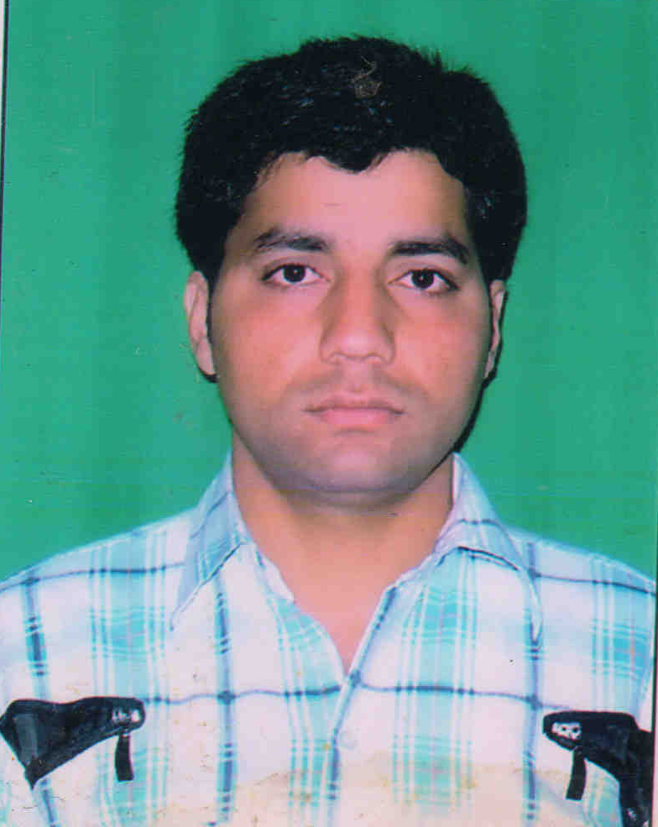
CURRICULUM-VITAE

sachin kumar
ADDRESS: -
C 45/3 Phase - 2
Vikas Nagar ,Uttam Nagar Mobile:+91- 9911265646
New Delhi-110059 +91- 9910902679
E-mail:-sachin.yadav933@yahoo.com

Post Applied For:
- Medical Laboratory Technician.

Career Objective:
To work in such a challenging environment where apart from getting opportunity to display my skills, it should also enable me to explore my capabilities so that I can prove myself to the organization.

Personal Skill:
Comprehensive problem solving abilities, excellent verbal and written communication skills, ability to deal with people politely, willingness to learn, good interpersonal skills.

# Professional Experience:
Current Employer: | Star Imaging & Path Lab (“NABL & ISO 9001:2008” certified lab), Tilak Nagar, New Delhi - 18
Duration: | 5th April, 2010 to till date
Designation: | Laboratory Technician
Previous Employer: | PUSHPANJALI CROSSLAY HOSPITAL; Vaishali Ghaziabad NCR U.P 201001, U.P.
Duration: | 1st April, 2009 to 31th March 2010
Designation: | Laboratory Technician.
Previous Employer: | Star Imaging & Path Lab , Tilak Nagar, New Delhi
Duration: | 16th June, 2008 to 31st March, 2009
Internship: | Hindu Rao Hospital, Malka Gunj Delhi from 1st Feb 2007 to 31st July 2007.

Key Skill:
- To maintain documented procedures and records for the inspection and verification.
- To ensure appropriate storage, preservation of reagent chemicals and supervise the releasing of reports.
- To maintain the Quality Control.

ANALYZER KNOWN:
(1) CLINICAL BIOCHEMISTRY & ELECTROLYTE ANALYZER:
  - Vitros of Johnshon & Johnshon(5600, 4600 & 3600)
  - Architect Modular of Abbott (Ci400 + i1000SR) & (Ci8000 + i2000SR).
  - Hitachi 902 Fully Automatic Biochemistry Analyzer.
  - I Lab-650 Clinical Chemistry System.
  - Accustar 650 Fully Automatic Chemistry System.
  - Erba CHEM-5 Plus V2 Semiauto analyzer.
  - EasyLyte PLUS Analyzer for Na/K/Cl.
  - Microlab 300 of MERCK Semiautoanalyzer.
  - Turbochem 100 Biochemistry Analyzer

(2) HEMATOLOGY ANALYZERS:-
  - Celltac F of Nihon Kohden
  - Cell Dyn Ruby of Abbott.
  - Cell Dyn 1700 of Abbott.
  - Sysmex KX 21 Hematology Cell Counter.
  - Lab Life H3D premier of WIPRO.
  - Sysmex poch-100i Hematology Cell Counter.
  - Swelab-alfa Hematology Analyzer.
  - Bio Red D 10

(3) HORMONES ANALYZERS & MANUAL ELISA:-

  - Advia Centaur*CP (Bayer) Fully Automatic Analyzer
  - Axsym of Abbott Fully Automatic Analyzer.
  - Architect Modular of Abbott (Ci400 + i1000SR) & (Ci8000 + i2000SR).
  - Elecsys of HITACHI (Roche).
  - Mini Vidas Fully Automatic Analyzer.
  - ELISA method (Manual) on Erba ELISA Reader.
  - Chemiluminescence method (Semiauto) on LUMAX 4101 of Lilac.

(4) COAGULATION ANALYZER:

  - VITALAB fibron I.
  - Humaclot DUO & Junior of Human.

(4) MICROBIOLOGY ANALYZER:

  - Mini API (Biomerieux) Fully Auto
  - Bact/Alert 3D 60 (Biomerieux) Fully Auto.

Education Qualification :
- 10th passed from U.P Board in year 2003 with Second Division (59.5 %).

- 12th passed from U.P. Board in 2005 with First Division (60.00 %).

- B.A from C. C. S University Meerut.

Professional Qualification :
- Bachelor of Science in Medical Laboratory Technology (BScMLT) from NIMS
University.

- Diploma in Medical Laboratory Technology (DMLT) from Punjab Technical
University.

Extracurricular Activities :
- Attended NABL Audits.
- Have a working knowledge of Internet.
- Knowledge of Basics of Fundamentals in computer.
- English typing speed – 30 words per minute.

Hobbies and Interest :
- Listening to music.
- Reading.
- Driving.

Personal Information:
Father’s Name: | Mr. Bhojveer Singh Yadav
Date Of Birth: | 16th March, 1988
Gender: | Male
Marital Status: | Unmarried
Nationality: | Indian
Languages Known: | English & Hindi

Declaration:-

I hereby declare that the particulars given here are true to the best of my knowledge & belief.

Date: . . . . . . . . . . . .

Place: New Delhi (Sachin kumar)

