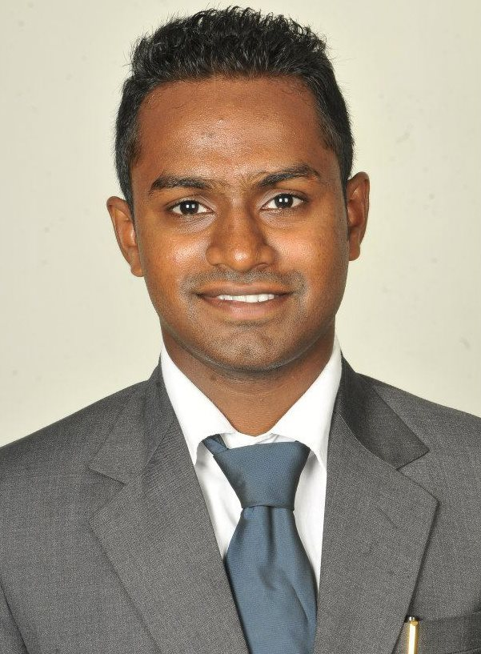
DENNY MICHAEL

(B.Sc. Nursing & MHA;
Kasturba Medical College, Manipal)
Post applied for : Staff Nurse
E mail id: - maildennymichael@gmail.com
Phone : +919818269907

Career Objective
Seeking a position as a nurse in a reputed hospital where I can enhance my nursing skills and medical knowledge and to serve patients with best nursing care possible.
Educational Qualification

Degree/Exam | Univ/Board | Institute | Year | Stream | Score (%)
Masters in Hospital Administration | Manipal University, Karnataka  (Regular) | Kasturba Medical College (K.M.C.), Manipal. | 2013 | Hospital and Healthcare Administration and Management | 60%
B.Sc. Nursing | Manipal University, Karnataka  (Regular) | Manipal College of Nursing, Manipal. | 2010 | B.Sc. Nursing | 61.3%
12th std | C.B.S.E, Delhi | K.E.S.S.S, Delhi | 2006 | Science | 64%
10th std | C.B.S.E, Delhi | K.E.S.S.S, Delhi | 2004 | General | 75%

Clinical Experience 2 years
Organization | Designation | Year | Job description
1. Kasturba Medical College (K.M.C.), Manipal | Staff Nurse | 2010-11 | Administering nursing care to patients in Medical ward and Surgical ICU.
2. Rafi Hospital,Bangalore | Staff Nurse | 2013-2014 | Administering nursing care to patient in ICU.

I.T. Skills

- Microsoft Office Package
- SPSS

Personal Details

Date of Birth: 29-12-1988
Gender: Male
Marital Status: Unmarried
Permanent Address: B-37/F-1, Aashiyana Apartments, Dilshad Colony,
Delhi – 110095.
Languages known: - English, Hindi, Malayalam, Kannada.

I, Denny Michael, confirm that all the information given above is correct to the best of my knowledge.

Denny Michael

