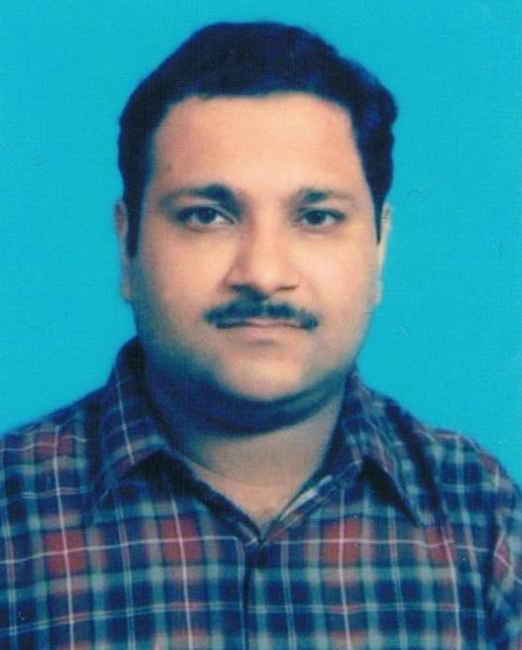
VANESH GULATI
C/o,WZ-276, ,
Inderpuri, New Delhi -110012
Email ;- gulvanesh@rediffmail.com
Mob.:8375964756/9911375190.
Date of Birth:-26.03.1965
Place of Birth:- Delhi
Martial Status:- Married
Language:- English, Hindi, Punjabi
SUMMARY
Skilled and dedicated offering an impressive and an exceptional understanding and proficient to provide comprehensive direction and solutions with sincerity and hard work in banking and accountancy.

Areas of Interest:

Banking & Accountancy.

EDUCATION

Bachelor of Commerce (Delhi University) India. 1985

XII- CBSE- Kendriya Vidayala- Delhi. 1982

X-CBSE- Kendriya Vidayala-Delhi 1980

PROFESSIONAL EXPERIENCE

Worked in State Bank of Saurashtra.-Delhi. | August 1987– August-2009
Work in State Bank of India- Delhi | 2009-2012
CAIIB-PART-I
- Collection and Generation of Daily bank Reports.
- Daily Progress bank Report.
- Preparation of Monthly bank Reports and presentation to Bank Manger.
- Monthly Turn Over- Bank Statement.
- Doing operational duties in bank at every bank counters- Handling Cash, Clearances, Accounts, vouchers etc.
- Knoweldge and Expertise in Tally, Microsoft and Excel.

DECLARATION

I here by declare that the information furnished above is true to the best of my knowledge.

(Signature)

