DIMPLE ANAND
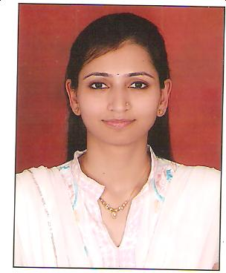
RU-213, Pitampura, Near Power House, Delhi-110034
Mobile : 9212309998 / 8505891008
E-mail : dimple_anand2002@yahoo.com

Academic Qualifications
- Post Graduate Diploma in Business Administration (specializing Human Resource Management) equivalent to MBA through Symbiosis, Pune in 2007-2009.
- Graduate in Commerce from Shaheed Bhagat Singh College, University of Delhi in 1996-1999.
- Two years (1994-96) full time Office Management from Central Board of Secondary Education, New Delhi.
- One Year (1998-99) Diploma in Tourism Studies from Indira Gandhi National Open University, New Delhi.
- Certificate Course in Computers – MS Office: MS-Word, Excel, Power-Point, Access, Adobe Page- Maker, Internet, Outlook Express & Tally.

1) August, 2010 till May, 2011 Training Manager
Integrated Disease Surveillance Project
National Institute of Communicable Diseases
(Ministry of Health and Family Welfare)
Job description:
- Development and Implementation of HR & Training Programmes.
- Monitor all India recruitment and trainings.
- Handled file management.
- Developing and upgrading relevant recruitment, training & development and evaluation material.
- Coordinating with senior staff to ensure that training and development meets current needs and anticipates to the extent possible future needs.
- Maintaining an account of the funds.
- Report writing and record keeping.

2) February, 2009- August, 2010 Monitoring & Evaluation Assistant
District AIDS Prevention & Control Unit (Delhi State AIDS Control Society)
Job description:
- Data handling and management of resources.
- Ensured timely and accurate formats submitted by the field staff.
- Maintained the district dashboard and updated it regularly.
- Updated the team members about the district situation in the monthly team meetings.
- Undertook all administrative duties.

3) April, 2007- October, 2009 Executive Secretary to Vice President (HRD & Admin.)
JAQUAR & COMPANY LTD

- Taking dictations, minutes of the meetings, making reports, drafting letters, e-mails and handling correspondence independently.

- Involved in forming job descriptions, finding candidates through consultants, web portals, referrals etc, taking interviews to shortlist candidates and Induction process for new recruits.

- Designing & implementation of Performance Management System. Offer / Appointment, Confirmation, Appraisals & Termination letters, Involved in designing of salary structures for new recruits.

- Involved in organizing & coordinating various training & development programs - In-house & External.

- Independently monitoring & keeping track of employees’ incentive schemes such as Holiday Incentive Scheme (Tour & Travel Management of the employees), Loan disbursement & Long Service Awards to the employees.

- Writing articles, designing lay-out and editing in-house quarterly magazine “NewsShower” as Chief Coordinator. Updating HR Manual & Employees database / directory from time to time.

4) January, 2000 till February, 2002 with CLIPS India P.Ltd. as Customer Service Executive
-Corporate Sales & Marketing Presentations, Merchandising, Stock-taking, corporate correspondence.

- Handled Billing, Challans, Purchase Orders, Quotations, DSR & other reports.

5) May, 1997 till March, 1999 with DSS Mobile Communication Ltd. (MOBI><Link) as Paging Service Representative

Personal Details
Date of Birth : 15th January, 1979

Husband’ Name : Mr.Sandeep Anand

(DIMPLE ANAND)

