CURRICULUM VITAE
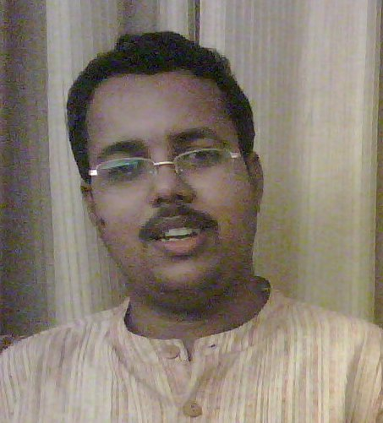

PERSONAL INFORMATION

Name : SAROSIJA BASU
Fathers Name : Late. Biswanath Basu
Date of Birth : 09 February 1983
Gender : Male
Nationality : Indian
Languages Known : English, Bengali, and Hindi

Address : Adhikari Para, Memari
Town + P.O. – Memari
Dist. – Burdwan
West Bengal
Pin – 713146
Phone – (0342) 2260106/ 9564637750/9609261444
Email: basu.sarosija@gmail.com

EDUCATIONAL QUALIFICATION:

Qualification | Year | Institute/University
PGDHM  (Post Graduate Diploma in Hospital Management) | 2008 | Pune University
MA, Sociology | 2007 | Pune University
BA (Hons), Sociology | 2004 | Burdwan University

COMPUTER CERTIFICATION
- Undergone training program on Office Applications from JNNYC-Council of education and training recognized by Govt. of India and obtained Grade-A.
- Well versed with MS Office (Word, Excel, Power Point), Internet concepts and Computer fundamental
INTERNSHIP:
I have done an Internship in KEM Hospital, Pune as hospital management trainee for a period of three months ( 01.01.09 to 27.03.09) as part of my PGDHM curriculum.
OTHER SPECIALIZATION:
I did my specialization on ‘Women Studies’ during MA, Sociology.

NATIONAL AND INTERNATIONAL SEMINAR AND WORKSHOP ATTENDED:
- International seminar of family violence and human rights (2 seminar on 2005-2006 and 2006-2007)
- Workshop on Current issues of health
- Reproductive health (Special focus on sexuality and violence)
- National seminar on De-notified nomadic tribe
- South Asian seminar on Exploring masculinity
- International seminar of Multiculture

PROFESSIONAL EXPERIENCE:

I have worked as Social Development Officer in M/s Infrastructure professional enterprises Ltd (M/s IPE Ltd.) from June 2010 to March 2015 on contract basis. I have been working for various urban development projects of Government of India like IHSDP, UIDSSMT, and JNNURM. The projects are implemented and monitored by State Urban Development Authority (SUDA) through M/s IPE Global Ltd.

AREAS OF EXPERTISE:

- Sociologist with an exposure to Methodology of social Research , Minority Group study, Human Settlement, Industry Development, Labour Organisation, Feminist Movement, Women Studies, Principal & Practice of Management in Hospital, Basic Accounting, Administration & Planning, Staff- Patient Relationship, Material Management & Inventory Control, Total Quality Management and Computer Fundamental.

- Working experience in Monitoring Physical and financial progress of development projects, Identifying bottlenecks in Field level implementation of assigned project and suggesting remedial measures in consultation with Urban Local Body, Municipal Engineering Directorate & State Urban Development Officer.
- Report preparation on beneficiary classification, PMR & AE/SAE remuneration. Guiding and assisting ULBs in preparation of claim for cost escalation for Dus, ID work. Preparation of proposal related to relocation/amalgamation & change in design for being considered in SLCC meeting.

REFERENCES
1. Dr. Swati Shirwadkar, HOD, Sociology Department, Univ. of Pune
Contact no: +912025469674; email: swati@unipune.ernet.in
2. Biswajit Das, TUO SUDA, ILGUS Bhavan, West Bengal, India.
Contact No: Call: + 91 9830654502; email: biswajit201030@yahoo.in
3. Lt. Col (dr) RK Bhaskar, EX-Director, HMI, KEM Hospita, pune
Contact no: 09413300364/ 09422035982

