Curriculum vitae 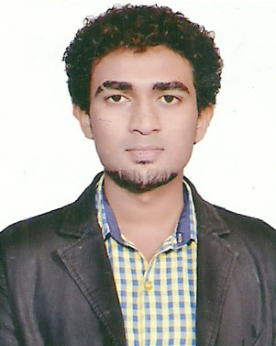
RAHUL KOLI

D.O.B:12/12/1993

ADDRESS: QTR NO 9 TYPE 2 VARUN KUNJ DJB STAFF QUARTER ROHINI SECTOR 5 NEAR RITHALA METRO STATION
NEW DELHI
PIN NO. 110085

CONTACT NO.- (+91)9868504905
8527128635
E-mail-RAHULKOLI8888@GMAIL.COM

FATHER’S NAME :
Sh. ARJUN KOLI

Professional Qualification :
Diploma in electrical engineering from guru nanak dev co-ed polytechnic board of technical education delhi in 2013

Education Qualification :

- Passed matriculation under C.B.S.E board delhi in2009 .

- Passed senior secondary under N.I.O.S board delhi in 2013 .

Extra curricular activity :
- Auto cad complete course from DELHI INSITITUTE OF TOOL ENGINEERING (GOVT. OF NCT OF DELHI)

Skill summary :

- Six weeks summer training in IN S.K.N BENTEX, NARAYNA DELHI

- 2 Year 1 month Working in ADICON INFRASTRUCTURE PVT. LTD. DELHI
AS A ELECTRICAL SUPERVISOR

- Currently working in vatech wabag ltd. (UNDER DELHI JAL BOARD ) As a OPERATOR .

Computer proficiency :

- Computer basics, ms-office (Word, power point, Excel),

Major Project :

Study of solar power energy.

Strength :

- Positive attitude, Punctuality, Confidence, Creativity & Hard Work, Self confidence, Smart working, Strong will power

Other information

Maritial status : Unmarried
Nationality : Indian
Language known : 1. Hindi
2. English
3.Marathi

Declaration:-

I hereby declared that the above statement are true to my knowledge & belief.

Date:………….
Place:…………. (Rahul koli)

